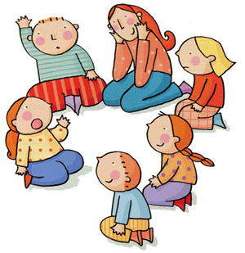

Working
On
Worship (20)
Helping children plan acts of worship using Flippin’ Praise

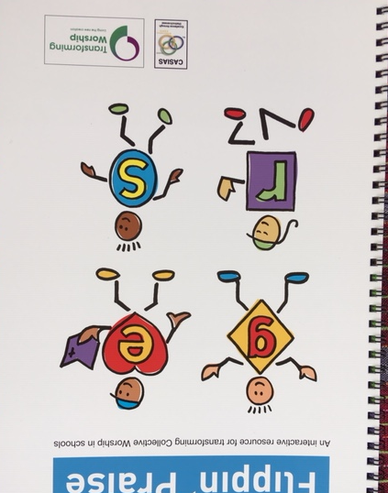
‘Flippin’ Praise’ is a simple A4 flip-book to help groups of children plan acts of worship in relation to a given theme. It also helps them become clearer about what Collective Worship is about. The book costs £10 (plus p & p) https://www.cofesuffolk.org/schools/resources-and-information/collective-worship/flippin-praise/
This paper summarises some of its main components and uses but you are encouraged to buy one or more copies for use with children. ‘Flipping’ the pages is all part of the fun!

A four-fold structure:
Flippin’ Praise uses a four-fold structure of Gathering, Engaging, Responding and Sending to plan school Collective Worship. This is used for several reasons:
- It is similar to the common format of ‘assembly’: welcome, story, song, prayer/ reflection, dismissal.
- The same structure relates to many Anglican acts of worship and for church schools may create recognisable links between school and church
- It is the structure recommended by the Liturgical Commission of the Church of England in their report ‘Transforming Worship’.
Choosing items for the four different sections helps children see a shape to worship and is the first step to good planning. Flippin’ Praise does not provide ready-made acts of Collective Worship. Children need to be given the theme for their Collective Worship before they use Gather – Engage – Respond – Send.
The Church of England have set up an interactive website called ‘Worship Workshop’. This helps you structure and plan school collective worship and includes songs and hymns for download, prayers for different seasons and so on. www.worshipworkshop.org.uk/‎
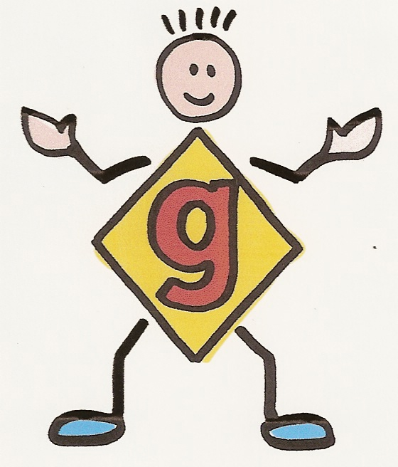
The Flippin’ Praise characters
Four cartoon characters are introduced in ‘For the Teacher’; they are a useful tool in planning as they summarise what should happen in each section of Collective Worship.
The cartoon characters are intended to be symbolic. The ‘Gathering’ figure, for example, reaches out to welcome everyone and smiles ready to offer a greeting. It encourages thinking about how children will arrive at the act of Collective Worship, what they will see or hear, how they should be greeted and what signals the start of worship.
G – E – R - S
In the early section of the book, the words Gathering, Engaging, Responding and Sending are defined simply for children (and expanded for adults) and simple questions are provided to help them think through what decisions must be made for each section. This is ideal preparation for the ‘worship team’ or a class.
Here is how the explanation and questions run for ‘Gathering’:
Gathering: We gather together and greet each other. We all come to play a part in this community. We are preparing to meet with God.
Think about the theme of your worship before you choose:

- How will you set up the room for worship? What will everyone do as they gather together?
- How will you greet people? Will you use a greeting from here?
- Will you say it, sing it or sign it? Will you find your own greeting from Psalms n the Bible?
- Who will be the LEADER? How will people know the RESPONSE?

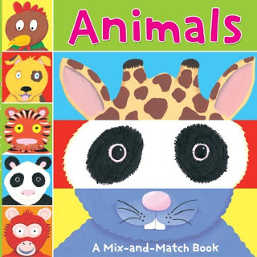
Let’s get flippin’
This section of the book is reminiscent of ‘mix and match’ books with heads, torsos and feet of strange animals. There are 12 flaps for each section of Gather – Engage – Respond – Send and so an incredible number of combinations from which children can create a Collective Worship outline. For example, flipping through the different sections might give the following structure to which children can then add.

Gather  (G9) | Listen to quiet music, light a candle and say:  Leader – The Lord is here.  Response – His Spirit is with us.
Engage  (E9) | Talk about a relevant personal experience or tell a story that fits the theme.
Respond  (R5) | Ask several people to say a short prayer and sing a reflective chant e.g. from Taize, after each one.
Send  (S10) | Leader – May God bless us and the work of our hands.  Response - Amen

Other uses
A simple copiable sheet at the back with all the character symbols can be used for recording your own ideas, ensuring something is chosen for each section. We have also seen it used as a form of assessment.
Working on Worship papers (Letting the Children Lead, Valuing and Evaluating CW and Early Years Children in CW) demonstrate other ways in which G-E-R-S can contribute effectively to Collective Worship in school. See www.cofesuffolk.org and follow schools, Collective Worship.
Sample acts of Worship using G-E-R-S
Below is a sample of an act of Collective Worship from the Lord’s Prayer Project CD based on the Gathering, Engaging, Responding and Sending approach, showing how it can be developed into a fully usable outline. NB In the pack there are introductory notes to this sample.
The Lord’s Prayer Project CD contains more than 30 different acts of Collective Worship as well as sung recordings of the Lord’s Prayer, an RE Theme day etc. Further details from www.cofesuffolk.org and it costs £15 (plus p and p).
Variations
One infant school simplified Flippin’ Praise further. They provided children with a larger number of sections but the sections referred to specific songs and prayers, a particular Bible Story book and so on. This created a first step for children in making their own acts of Collective Worship
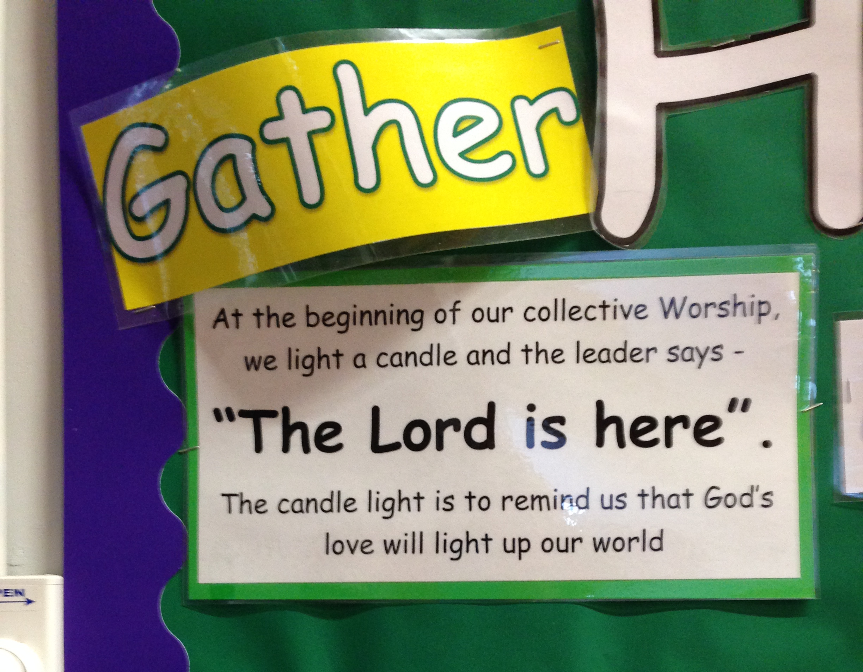

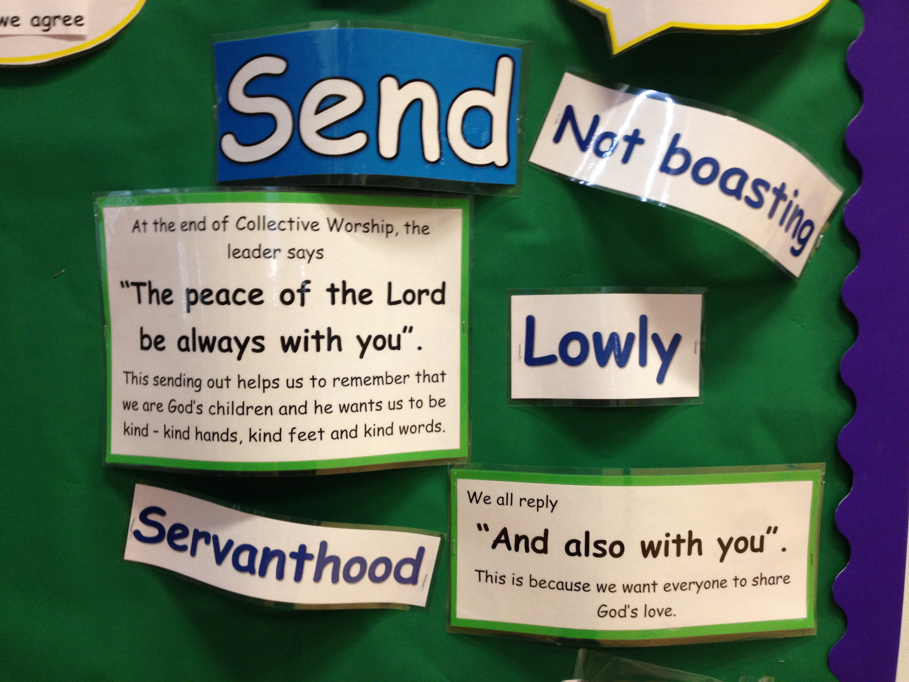
Sample act of worship following G-E-R-S pattern:
Gathering
Choose what is appropriate:
- Play ‘Our Father’ by Bankhead and Burn, or invite a choir or class to sing it and encourage other children to join in or to hum along.
- Display WWJD boxes so children can see them.
- Say Good Morning or use a liturgical greeting and response e.g. Peace be with you / and also with you.
Engaging
- Show a basketful of bracelets or line up a group of children wearing bracelets. What different types of bracelet are there?
- Sometimes Christians have to make hard decisions. Point to the WWJD boxes. WWJD means ‘what would Jesus do’. Produce a WWJD bracelet, show on projector or make by writing letters on a paper strip and stapling together. Wearing the bracelet reminds Christians to pray for Jesus’ help.
- Long ago the disciples had to ask Jesus how to pray; they weren’t sure. Jesus obviously knew how to pray; he even got up early to pray to God. Listen to a child read: Luke 11:1-4.
- Cut out a card crown to show children. Say you’ve found something new to help Jesus’ followers; it’s called a Lord’s Prayer bracelet. It is created by using objects like this crown but tiny, and various coloured beads, a bit like a charm bracelet. Show if possible.
- Most importantly it helps you remember the words of the prayer and to pray it. Repeat the Lord’s Prayer slowly. Ask children to think of ideas for objects or colours of beads to thread on the bracelet e.g. a miniature loaf of bread, a tiny cross, bright blue beads for heaven.
- I wonder if every Christian should go out and buy or make a bracelet like this. Should every Christian wear one? What would Jesus do?
Responding
Light a candle by a copy of the Lord’s Prayer and invite children to place the bracelets and the WWJD boxes nearby. Sing the ‘Our Father.’
Reflect: I wonder how you remember the right things to do.
Prayer: Dear God, remind me what the right things are to do when it is hard to decide. Amen. Blow candle out.
Sending
- Challenge classes to create a giant Lord’s Prayer bracelet and deliver it to you for a prize.
- Maybe close with a liturgical ending e.g. Go in peace to love and serve the Lord / each other. Leave singing ‘Our Father’ (Bankhead and Burn).

