EYFS How can we care for our wonderful world?
What should we know?

Christians believe:
- The Bible tells the story of God creating the world.
- God has given the world to people to look after.
- We are all caretakers of our wonderful world.
- God is pleased when we work with others to look after our world.
Christians:
- May hold special services in church for pets or our world.
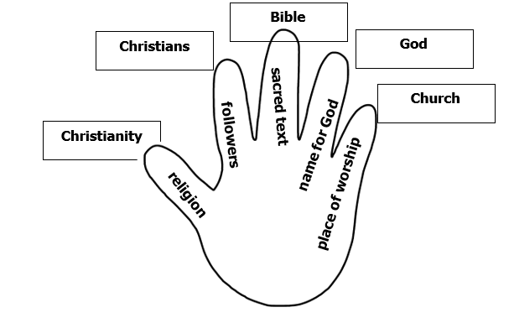
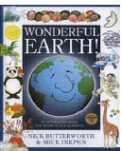
What should we be able to do?
Remember the different things created by God in the Bible story of creation.
Recognize something a Christian does because they believe God wants them to care for the world.
Give examples of how to be a good caretaker of the world.
Vocabulary
God | Christian | Caretaker
Jesus | world | wonderful
Bible | creation | design
church | responsible

