Clergy Housing Handbook

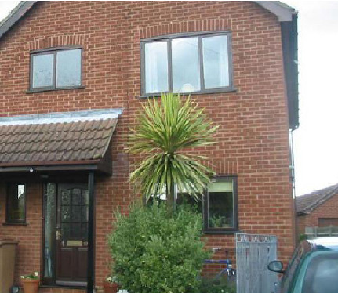
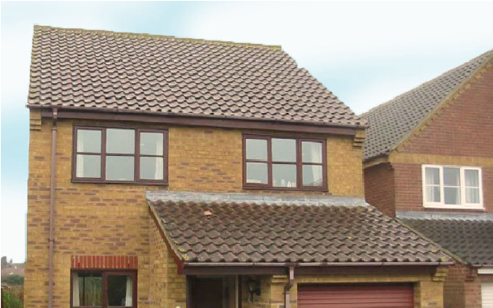
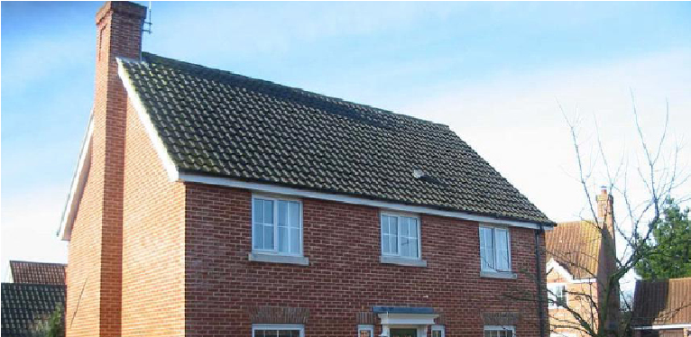
Revised: March 2022
Contents

Forward from the Chair of the Parsonages Committee 3
The Purpose of this Booklet is to 3
Responsibilities of the Parsonages Committee 4
Responsibilities of the Resident 5
The Periodic Inspection Process 6
What to do About Repairs 6
In an emergency 7
Safety and Security 7
Gas 7
Electricity 7
Trees 7
Smoke Detectors 7
Asbestos 8
Condensation 8
Disability 8
Water Softeners 8
Security 8
Lodgers and refugees 8
Moving House 8
When moving in 9
When moving out 9
Letting of vacant properties 10
Useful names and addresses 11

Forward from the Chair of the Parsonages Committee
Welcome to the Diocese of St Edmundsbury & Ipswich.
This Guide has been prepared by the Property Team to help occupants of Diocesan houses and their families with the management of their home. It seeks to explain how the system of maintaining our houses works, and to set out clearly who is responsible for what, and when.
Responsibility for maintaining the property is shared between the Diocese and the occupants; this Guide seeks to provide information for occupants about how these responsibilities are to be met. The Parsonages Committee hopes that gathering this information in one document will prove useful to all involved and enable us together to care for the property wisely yet prudently, and hand it on in a good state for our successors.
The Diocese takes the lion’s share of responsibility and maintains the structure and fabric of the building and the services to it. This includes such things as general repairs and maintenance, improvement works, payment of council tax, water rates and buildings insurance, etc. The occupant has a duty to take care of the house and gardens and to act as a good steward for the duration of their tenure. The parish plays an important role during vacancy and leading up to the arrival of the new clergy occupant. If you have any concerns about your clergy home please get in touch with the property team who will be glad to do what they can to help.
Ian Wigston
Chair of the Parsonages Committee
Trustee of the DBF

The Purpose of this Booklet is to
- Explain how the system of maintaining diocesan houses works.
- Set out the rights and duties of all involved.
- Explain the procedures in case of emergencies.
- Provide answers to many routine questions.

If you become aware of any building maintenance or repair issues, then please report them as soon as possible to the diocesan office staff on 01473 298512 or via email to: property@cofesuffolk.org

Standard of Clergy Housing
We aim to provide the most modern, cost efficient and comfortable accommodation possible within the constraints of location and budget. The standard of accommodation for clergy housing will usually provide:
- four bedrooms,
- a separate study,
- a ground floor cloakroom,
- first floor family bathroom, with separate WC,
- second shower room/bathroom or en suite,
- two reception rooms,
- kitchen, with separate utility space,
- a single-space garage, with separate off-road parking.

Sometimes it is simply not possible (or necessary) for all the criteria to be met and some flexibility may be required where exceptions to the basic standard cannot be avoided, for example:
- where special needs exist,
- where the location means that a property providing the standard accommodation is not readily available.

Responsibilities of the Parsonages Committee
- To maintain the structure and exterior of the building (walls, roofs, windows, doors, gutters, drains etc.).
- To provide and maintain the installations for the supply of heating, water, utilities and sanitation.
- To make payments in respect of council tax, water/sewerage rates and building insurance (but not contents insurance).
- To maintain all fixtures and fittings belonging to the house listed on the latest periodic inspection report.
- To decorate and maintain public rooms (the downstairs WC, the hall, stairs, landing and study) in neutral colours.
- To have smoke and carbon dioxide detectors fitted in the premises.
- To provide flooring for wet areas (kitchen, utility room, WCs and bathrooms) and studies, halls, stairs and landings.
- To provide basic curtain track fittings to each window or to provide blinds to certain windows on a discretionary basis.
- To supply shelving to studies.
- To maintain integrated cookers and hobs. Where integrated dishwashers are fitted and they break down beyond economic repair, the kitchen base unit will be adapted to suit a freestanding dishwasher which would be supplied and maintained by the incumbent.
- To have the property inspected at intervals and to provide the resident with a copy of the report.
- To prioritise and carry out improvement work when and where appropriate and as funds permit.
- To manage through the Periodic Inspection process (and as required in the intervening period), any large trees at the property (excluding modest fruit trees, hedges and shrubs).
- To provide a BT point in the study.
- To maintain boundary fences and hedges.

Responsibilities of the Resident
- To report any repairs and maintenance issues particularly leaking taps or toilets as soon as possible (water leakage now measurable through the water meters) – refer to “What to do” section.
- To implement and pay for any repairs made necessary by misuse, neglect or damage, including damage caused by animals. This may include any costs incurred for drain clearance, e.g. where blockages have been caused by fat deposits or toilet wipes.
- To maintain internal decoration in good order. Non-public rooms may be painted in a colour of choice, yet décor must be returned to a neutral colour at the cost of the resident prior to vacating the premises. Public rooms (the downstairs WC, the hall, stairs, landing and study) are decorated and maintained by the diocese in neutral colours although other colours may be permitted at the discretion of the relevant archdeacon and the Head of Property.
- To provide and replace all floor coverings as required excepting the wet areas, study, hall, stairs and landing, which will be provided with vinyl floor covering and carpet respectively. Woodblock flooring will be subject to occasional major refurbishment but the general sanding, staining and polishing of these surfaces is the responsibility of the resident.
- To provide and repair any appliances (the Parsonages Committee will endeavour to provide standard 600mm spaces for typical appliances).
- To maintain all garden areas including hedge trimming, pruning of fruit trees, shrubs, grass cutting, beds & borders and keeping driveways and paths free of weeds. Please refer also to the safety section. Failure to maintain the garden in reasonable order may result in the relevant archdeacon appointing a gardener to do so at the incumbent’s expense.
- To provide any fencing required to keep pets within bounds.
- To make arrangement for the installation and maintenance of all radio or TV aerials and satellite dishes and ensure that they conform to local planning constraints.
- To ensure adequate home contents insurance – strongly recommended. All personal belongings are the responsibility of the resident.
- To advise the diocesan office staff if the property is to be unoccupied for more than 28 days – this is an insurance requirement and will affect cover if not pre notified.
- To report immediately to the diocesan office staff any problems that may lead to structural damage if left unattended or any damage that may be subject to an insurance claim.
- To keep pre-arranged appointments with contractors and to give access to the Diocesan Surveyor.
- To inform the diocesan office staff of work not carried out within a reasonable timeframe.
- To seek consent from the diocesan office staff before installation for any cat or dog flaps and to meet the costs of installation and reinstatement when vacating the property.
- To pay for any installation, rental or maintenance costs associated with the telephone service regarding personal phonelines.
- To make arrangement for chimneys and for wood-burners in use to be regularly swept or inspected (HETAS recommends one or twice a year depending on usage).
- To report immediately to the diocesan office staff any notices or letters received from statutory bodies such as Local Authorities, HM Land Registry or Historic England. This is particularly important where notice is received of a nearby planning application.
- To note that no part of the premises may be used for any purpose other than as a domestic dwelling. The use of the premises for commercial business use is strictly prohibited.
- The property may not be altered in any way without the consent of the Property Committee. Work organised at the occupier’s cost and under the supervision of the Diocesan Surveyor may be permissible.
- To provide and maintain any garden sheds that do not form a part of the structure of the house.
- When moving from the property, to clear all personal belongings from the house, loft, outbuildings, garage and garden – any costs incurred for removal may be recharged to the resident.
- For those served with oil boilers – to ensure the oil levels are maintained. Call outs and works where oil has run dry and the boiler failed will be rechargeable.
Responsibilities of the Diocesan Surveyor
- To monitor and supervise maintenance and improvement work where necessary.
- To manage letting of properties where there is a vacancy.
- To provide advice as required for purchases and sales.
- To complete a periodic inspection of each property, at a time arranged with the resident.

The Periodic Inspection Process
- The Diocesan Surveyor, by prior arrangement with the resident will inspect the property at intervals not exceeding five years, wherever possible.
- Following the inspection, the Diocesan Surveyor will produce a comprehensive report giving answers to certain questions (as required by the Repair of Benefice Buildings Measure 1972), and a schedule of repairs.
- A copy of the report is sent to the resident together with a notice stating his/her right to make representations and the date by which the representations must be made.
- The Diocesan Surveyor will arrange for contractors to visit the property to obtain competitive tenders for the repairs and any external decoration recommended.
- The reports and representations are then considered at the next available meeting of the Property Committee.
- Any recommended improvement will be added to the list of outstanding improvements. These are prioritised and are addressed from time to time and as funds allow. Some improvements are, more logically, carried out during an interregnum.
- So long as the total cost of the repair works is within the budget allocation, the Property Committee will instruct the Diocesan Surveyor to place orders for the work External works, particularly redecoration, will generally be carried out during the summer following the inspection.
- The Diocesan Surveyor will oversee the work, dealing with all queries and contract instructions, including following satisfactory completion of the work, authorising payment of the contractor’s final account.
- All periodic inspection work should be completed by the end of October in the year following the inspection.

What to do About Repairs

If you become aware of any building maintenance or repair issues, then please report them as soon as possible to the diocesan office staff on 01473 298512 or via email to: property@cofesuffolk.org

In an emergency
- In diocesan office hours:
Contact the diocesan office on 01473 298512
- Outside office hours:
If you have an urgent repair/issue which cannot wait until the office re-opens, you can contact the following contractors who have agreed to provide emergency cover:
Heating (gas/oil) and plumbing
EPPH – 01473 559071

Electrics
EPPH – 01473 559071

Door and window repairs
Ipswich Glass and Glazing – 07790 201045

(N.B. interim emergency arrangements are organised during statutory holiday periods such as Christmas and Easter and you will be advised accordingly).
- De Minimis:
Strictly Emergency works outside of office hours of up to £300 may be undertaken without the prior consent of the diocesan office staff or relevant archdeacon. The resident should pay the contractor and forward the invoice and confirmation it has been paid to the diocesan office with bank details and it will be reimbursed to your bank account.

Safety and Security

Gas
Annual safety checks on central heating boilers and other gas appliances are arranged by the diocesan office staff to comply with the Gas Safety Regulations. Prior authorisation must be obtained before any alternative arrangements are made.
Oil
Annual safety checks on central heating boilers are arranged by the diocesan office staff to comply with the OFTEC recommendations.

Electricity
Periodic Testing is organised by the diocesan office staff and undertaken in accordance with current recommendations. Prior written approval must be obtained for any alterations or adaptation of fixed wiring electrical installations or equipment. Occupiers are responsible for their own appliances. If an appliance is found to be faulty, the Diocese electricians will disconnect the appliance and leave it with the incumbent for disposal.

Trees
Many trees are subject to Local Authority protection. Therefore, no work (annual pruning excepted) is to be carried out without consultation with diocesan office staff. Please inform the diocesan office if you have any concerns regarding the trees in your garden.

Smoke Detectors
At least two will normally be provided. Residents should test the alarms weekly and report any faults to the diocesan office.
Carbon Monoxide Detectors
At least one will normally be provided. Residents should test the alarms weekly and report any faults to the diocesan office.

Asbestos
To ensure the safety of our occupiers and contractors, and in accordance with the Control of Asbestos at Work Regulations (2012), the Property Committee has undertaken a survey for the presence of asbestos at all homes. A copy of the report should be available at the property for inspection by residents and visiting contractors. Please ensure that you familiarise yourself with the report and report any disturbance of asbestos containing materials (ACMs) to the diocesan office staff immediately.

Condensation
Condensation is a problem which has become more prevalent since standards for modern construction have changed. When warm moist air, produced naturally through daily living meets cold surfaces, water droplets within the air will condense on the cold surfaces such as windows and cold areas of wall. In due course, prolonged moisture build-up may result in mould growth or timber rot.
Installation of replacement double-glazing, draft exclusion, closure of chimneys and replacement doors are all factors which are likely to reduce natural ventilation within a property. The consequence of this is that warm moist air is unable to escape to the open air. The Property Committee aims to reduce issues of condensation through providing extractor fans to kitchens and bathrooms
Residents can play their part in reducing condensation by ensuring that:
a) washing is not dried within the house,
b) extractor fans are used where possible,
c) the property is kept adequately warm,
d) the property is ventilated through opening windows and doors as moisture is produced.

Disability
The parsonage house is considered a domestic dwelling with public access by invitation. Where practical, assistance in providing improved access will be considered.

Water Softeners
These are not generally provided but where they are fitted, the resident is responsible for maintenance.

Security
Suffolk is generally regarded as one of the safest counties within which to reside. Some houses have limited security devices (alarms, external lighting etc.). These are not generally provided by the Property Committee but where they exist, maintenance and servicing are the responsibility of the resident.
Lodgers
You are permitted to invite lodgers to stay with you providing the property team have been notified in advance and the agreement form completed (sent out when application made). It is essential that we are made aware of lodgers as we have to notify our insurers and notify Council Tax if we are claiming single person allowances. You may charge for lodgers but remain responsible for any tax implications.
Refugees
You are permitted to invite refugees to stay with you providing the property team have been notified in advance and the agreement form completed (sent out when application made). It is essential that we are made aware of refugees as we have to notify our insurers. The Government have applied special rules to the Ukrainian Refugee situation and their advice must be follow at all times.

Moving House

As far as possible, the Parsonage Committee and Archdeacons will ensure that houses are in good condition and ready to receive new residents. Repairs will usually have been completed where necessary, although it should be noted that most external repairs and maintenance works are completed following periodic inspections and not at the time of vacancies. Where the Property Committee has agreed, improvement works will have been completed prior to the property being re-occupied but subject to available budget provision. It is hoped that the internal decorative order has been left in an acceptable standard by previous occupants. There will normally be an opportunity for incoming clergy to view the house and meet with the diocesan surveyor and Archdeacon prior to the move. The property department will arrange for a removal company to survey your current home and will liaise with you regarding your moving date. Removal fees will usually be met by the diocese (up to a capacity of 56 M3 – excess to be paid by the incoming incumbent).

When moving in
- Arrange for the supply of gas and electricity service accounts to be transferred into your name. The diocesan office staff can usually provide the current suppliers’ details.
- It is recommended that the telephone service is in the name of the PCC and arrangements made for private use.
- Ensure that the correct amount of Council Tax and other charges are levied by informing the diocesan office of the moving dates and the number of adults living in the house (NB: there is a discount for a single person). Please deal directly with the Diocesan office and not the local authority as the payment is made by us
- Where the boiler is oil-fired, establish whether a top-up of oil is required in advance of your move.
- Ensure that your cooker will connect to the electricity or gas supply at the property.
- Consider the access arrangements at your current property and alert the removal firm to any concerns regarding access.

When moving out
When moving out you will receive a letter from the Archdeacons’ PA several weeks in advance of your move, detailing the arrangements which should be made. This will include a form to fill in, covering amongst other things: scheduled moving date; utility supplies; heating system; telephone service; keys; security; house contents, garden and the condition of the property. Please feel free to contact staff at the diocesan office if you have any queries. Please ensure all keys are returned to the Diocesan Office/Surveyor or left in the house. This can be discussed with the surveyor during the vacancy survey. If churchwardens require keys for viewings etc separate arrangements will be made. This is for insurance and health and safety purposes.
When moving to a new post/retiring
When moving to a new post or retiring, you will be required to vacate the house within one month of the date of your last service (in accordance with the Ecclesiastical Offices (Terms of Service) Regulations 2009). If for some reason you are unable to vacate, this needs to be discussed with your Archdeacon at the earliest occasion. Any extensions may be subject to payment of market rent on the house along with council tax and utilities for the extended period
Death in Service
Should you pass away whist living in your house, any member of your household who resides with you may stay in the house for up to three months from the date of your death (in accordance with the Ecclesiastical Offices (Terms of Service) Regulations 2009). Your Archdeacon would be in touch with your family to discuss arrangements and agree a relocation plan.
General
Please ensure that all personal possessions are removed and leave the house, loft and outbuildings in a clean condition ready for a new occupier and as you would expect to find them.
We will arrange to carry out an inspection within the last 2 months to help with any concerns you may have with the move and to discuss any works required to the house before you leave. As this is a busy time for you there are a number of services which we can assist with on a chargeable basis –
- Rubbish removal from house/garden including skip hire £300
- Cleaning inside of house including inside of kitchen cupboards £250
- Carpet cleaning (any number of carpets) £150
- Grass cutting £100
- Redecoration (per room) to neutral colour £350
- Replacement of lost keys (per set) £ 75
If you wish to use the above service please contact property@cofesuffolk.org or discuss with the Diocesan Surveyor/Archdeacon during the moving out property inspection.

Letting of vacant properties
Clergy houses usually fall vacant only in a vacancy or pending pastoral reorganisation and/or the sale of the house. The primary consideration of the Parsonage Committee is to support ministry through the provision of good houses. This may mean that on occasions the house is kept empty for a short period pending an appointment of a new minister. However, in most cases vacancies will last at least six months and the principles of good stewardship have led the Parsonage Committee to adopt a policy of letting vacant clergy houses. This approach offers many benefits including deterring vandalism, keeping the house properly maintained, avoiding adverse comment on leaving houses empty and generating rental income. Income from rental receipts are used to improve income at diocesan level and in turn are used to keep parish share as low as possible.

Useful names and addresses
Archdeacon of Sudbury  The Ven. Dr David Jenkins  Sudbury Lodge  Stanningfield Road  Great Whelnetham  Bury St Edmunds  IP30 0TL  Tel: 01284 386942/07900990073  archdeacon.david@cofesuffolk.org | Archdeacon of Suffolk  The Ven. Jeanette Gosney Park Road  Ipswich  IP1 3ST  Tel: 07710479497  archdeacon.jeanette@cofesuffolk.org
Archdeacon of Ipswich  The Ven. Rhiannon King  c/o The Diocesan Office  St Nicholas Centre  4 Cutler Street  Ipswich  IP1 1UQ  Tel: 07595880584  archdeacon.rhiannon@cofesuffolk  .org | Head of Property and Diocesan Surveyor  Mrs Dawn Gillett  The Diocesan Office  St Nicholas Centre  4 Cutler Street  Ipswich  IP1 1UQ  Tel: 01473 298507/07469149744  property@cofesuffolk.org
Chairman of the Property Committee

Mr Ian Wigston
c/o The Diocesan Office
St Nicholas Centre
4 Cutler Street
Ipswich
IP1 1UQ

