Assistant Curate Housing
Handbook

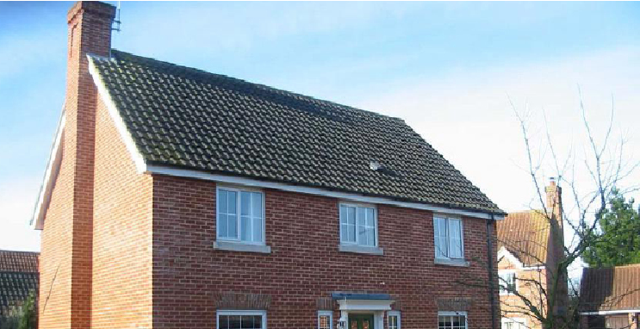
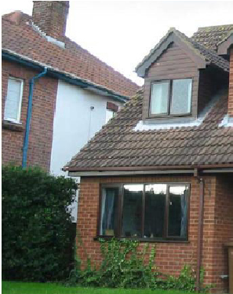
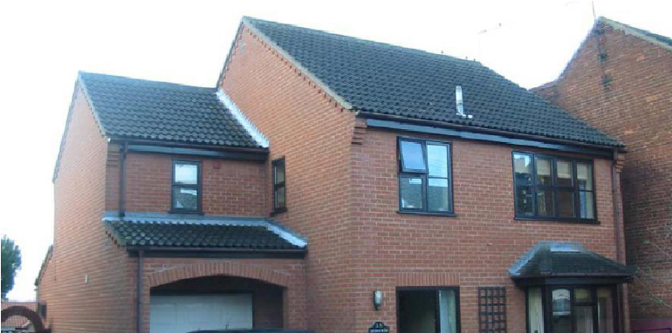

Updated March 22
Contents
The Aim of the Parsonage Committee 3
The Purpose of this Booklet is to 3
Especially for Assistant Curates – Title Post Housing 4
Process 4
Standards of Accommodation for Assistant Curates 4
Responsibilities of the Parsonage Committee 5
Responsibilities of the Resident 5
Location and availability 6
Good stewardship 6
Visiting the house 7
Administrative Matters 7
Moving in 7
Moving out 7
In an emergency 7
Safety and Security 8
Gas 8
Oil 8
Electricity 8
Trees 8
Smoke Detectors 8
Carbon Monoxide Detectors 8
Asbestos 8
Condensation 8
Disability 9
Water Softeners 9
Security 9
Lodgers and Refugees…………………………………………………………………………………………………….9
And finally 9
Useful names and addresses 10
Diocesan Director of Ordinands and New Ministries 10
The Revd Tim Jones 10
c/o The Diocesan Office 10

The Aim of the Parsonage Committee
To provide and maintain good quality cost effective housing to support clergy in their ministry.

The Purpose of this Booklet is to
- Explain how the system of maintaining diocesan houses works.
- Set out the rights and duties of all involved.
- Explain the procedures in case of emergencies.
- Provide answers to many routine questions.

If you become aware of any building maintenance or repair issues, then please report them as soon as possible to the property team on 01473 298512 or via email to: property@cofesuffolk.org

Especially for Assistant Curates – Title Post Housing
These days, assistant curates are no longer only placed in parishes that can afford to buy a house and therefore the provision of their accommodation is not regarded as a parochial responsibility but as the responsibility of the Diocesan Board of Finance (DBF). The St Edmundsbury & Ipswich DBF is committed to providing appropriate accommodation for all those entering ministry.

Process
When the decision has been made to place an assistant curate with a Training Incumbent, the Diocesan Director of Ordinands (DDO) informs diocesan office staff, and they and the archdeacon will start the process of finding suitable accommodation.
Consultation takes place with the training incumbent regarding location and then trained diocesan staff begin to look for a suitable property. Members of the local church are encouraged to make suggestions about possible properties, but all negotiations are carried out by diocesan office staff to ensure the integrity of the purchase process. When the legal purchase process of a suitable property has begun, your incumbent will be informed.
In some instances, of course, an assistant curate’s house will already be available within the area and this will normally be retained for the new title post holder. Replacement of an existing house is only undertaken in the most exceptional circumstances.

Standards of Accommodation for Assistant Curates
We aim to provide the most modern, cost efficient and comfortable accommodation possible within the constraints of location and budget. The standard of accommodation for title post holders will usually provide:
- three bedrooms
- two separate reception spaces
- kitchen (with separate utility space if possible)
- ground floor cloakroom

Sometimes it is simply not possible (or necessary) for all the criteria to be met and some flexibility may be required where exceptions to the basic standard cannot be avoided, for example:
- where special needs exist
- where the location means that a property providing the standard accommodation is not readily availably
- where it proves difficult to find a property with two separate reception rooms

Responsibilities of the Parsonage Committee
- To maintain the structure and exterior of the building (walls, roofs, windows, doors, gutters, drains etc.).
- To provide and maintain the installations for the supply of heating, water, utilities and sanitation.
- To make payments in respect of council tax, water/sewerage rates and building insurance (but not contents insurance).
- To maintain all fixtures and fittings belonging to the house listed on the latest periodic inspection report.
- To decorate and maintain public rooms (the downstairs WC, the hall, stairs, landing) in neutral colours.
- To have smoke and carbon dioxide detectors fitted in the premises.
- To provide flooring for wet areas (kitchen, utility room, WCs and bathrooms), halls, stairs and landings.
- To provide basic curtain track fittings to each window and to provide blinds to certain windows on a discretionary basis.
- To maintain integrated cookers and hobs.
- To have the property inspected at intervals not exceeding five years and to provide the resident with a copy of the report.
- To prioritise and carry out improvement work when and where appropriate and as funds permit.
- To manage through the Periodic Inspection process (and as required in the intervening period), any large trees at the property (excluding modest fruit trees, hedges and shrubs).
- To provide a BT point for business use only
- To maintain boundary fences and hedges.

Responsibilities of the Resident
- To report any repairs and maintenance issues – refer to “What to do” section.
- To implement and pay for any repairs made necessary by misuse, neglect or damage, including damage caused by animals. This may include any costs incurred for drain clearance, e.g. where blockages have been caused by fat deposits or toilet wipes.
- To maintain internal decoration in good order. Non-public rooms may be painted in a colour of choice, yet décor must be returned to a neutral colour at the cost of the resident prior to vacating the premises.
- To provide and replace all floor coverings as required excepting the wet areas, hall, stairs and landing, which will be provided with vinyl floor covering and carpet respectively. Woodblock flooring will be subject to occasional major refurbishment but the general sanding, staining and polishing of these surfaces is the responsibility of the resident.
- To provide and repair any appliances (the Property Committee will endeavour to provide standard 600mm spaces for typical appliances).
- To maintain all garden areas including hedge trimming, pruning of fruit trees, shrubs, grass cutting, beds & borders and keeping driveways and paths free of weeds. Please refer also to the safety section. Failure to maintain the garden in reasonable order may result in the relevant archdeacon appointing a gardener to do so at the incumbent’s expense.
- To provide any fencing required to keep pets within bounds.
- To make arrangement for the installation and maintenance of all radio or TV aerials and satellite dishes and ensure that they conform to local planning constraints.
- To ensure adequate home contents insurance – strongly recommended. All personal belongings are the responsibility of the resident.
- To advise the diocesan office staff if the property is to be unoccupied for more than 28 days.
- To report immediately to the diocesan office staff any problems that may lead to structural damage if left unattended or any damage that may be subject to an insurance claim.
- To keep pre-arranged appointments with contractors and to give access to the Diocesan Surveyor.
- To inform the diocesan office staff of work not carried out within a reasonable timeframe.
- To seek consent from the diocesan office staff for any cat or dog flaps and to meet the costs of installation and reinstatement when vacating the property.
- To pay for any installation, rental or maintenance costs associated with the telephone service regarding personal phonelines.
- To make arrangement for chimneys and for wood-burners in use to be regularly swept or inspected (HETAS recommends one or twice a year depending on usage). Certificate to be supplied to Diocesan Surveyor
- To report immediately to the diocesan office staff any notices or letters received from statutory bodies such as Local Authorities, HM Land Registry or Historic England. This is particularly important where notice is received of a nearby planning application.
- To note that no part of the premises may be used for any purpose other than as a domestic dwelling. The use of the premises for commercial business use is strictly prohibited.
- The property may not be altered in any way without the consent of the Property Committee. Work organised at the occupier’s cost and under the supervision of the Diocesan Surveyor may be permissible.
- To provide and maintain any garden sheds that do not form a part of the structure of the house.
- When moving from the property, to clear all personal belongings from the house, loft, outbuildings, garage and garden – any costs incurred for removal may be recharged to the resident.
- To arrange and pay for brown garden bins if required.
- For those served with oil boilers – to ensure the oil levels are maintained. Call outs and works where oil has run dry and the boiler failed will be rechargeable

Location and availability
The curate’s house will nearly always be within the benefice for which the training incumbent has responsibility and consultation will have taken place with the incumbent at an early stage to establish preferences regarding location. However sometimes factors surrounding the allocation of title posts mean that it can be very difficult to acquire a property of the required standard in the preferred location at the right time. Careful planning is also needed to ensure a property neither stands vacant for too long prior to occupation, nor its purchase is too last minute for peace of mind. This may particularly be the case in a difficult property market or where the period between a decision to proceed with a title post and the ordination date is very short. But, although guarantees cannot be made, it is aimed to get as close to the required location and standard as possible

Good stewardship
We are committed to providing you with the best possible accommodation both within the constraints mentioned and alongside good stewardship of diocesan resources. Even within the diocese, house prices vary considerably from place to place and therefore properties of varying values may be acquired taking into consideration their investment return and ability to be resold. However, our first concern is always the delivery of good quality accommodation to support those in ministry

Visiting the house
It is not usually possible to visit a property prior to completion of its purchase. Your Training Incumbent will be kept fully informed of progress during the acquisition process and you should feel able to be in touch with him or her if you have any concerns during this stage. As soon as the purchase has been completed you will be invited to visit.

Administrative Matters
As your ordination approaches you will receive a letter from the Archdeacons’ PA dealing with many administrative matters including arrangements for your stipend, removal, resettlement and first appointment grants. The HR Assistant or Property Administrator at the diocesan office will be happy to deal with any queries you may have about these practical aspects.

Moving in
Every effort will be made to ensure that your move is as smooth as possible and that any work required to the house will be completed prior to your arrival. It is expected a house will be ready for occupation approximately one month prior to ordination. Maintenance of your house will be supervised by diocesan office staff and overseen by the Parsonage Committee and archdeacons, applying the same principles as are outlined earlier in this housing booklet.

Moving out
At the end of your Curacy we will arrange to carry out an inspection within the last 2 months to help with any concerns you may have with the move and to discuss any works required to the house before you leave. As this is a busy time for you there are a number of services which we can assist with on a chargeable basis –
- Rubbish removal from house/garden including skip hire £300
- Cleaning inside of house including inside of kitchen cupboards £200
- Carpet cleaning (any number of carpets) £100
- Grass cutting £100
- Redecoration (per room) to neutral colour £350
- Replacement of lost keys (per set) £ 55
If you wish to use the above service please contact property@cofesuffolk.org or discuss with the Diocesan Surveyor/Archdeacon during the moving out property inspection.

In an emergency
- In diocesan office hours:
Contact the property team on 01473 298512.
- Outside office hours:
Instruct a local contractor to carry out sufficient work to resolve the emergency. Report the repair, together with its cost to the diocesan office staff as early as possible. (N.B. Interim emergency arrangements are organised during statutory holiday periods such as Christmas and Easter and you will be advised accordingly).
- De Minimis:
Emergency works of up to £300 may be undertaken without the prior consent of the diocesan office staff or relevant archdeacon. The resident should inform the contractor/s that invoices must be made out to the Diocesan Board of Finance and sent to the Diocesan Office.

Safety and Security

Gas
Annual safety checks on central heating boilers and other gas appliances are arranged by the diocesan office staff to comply with the Gas Safety Regulations. Prior authorisation must be obtained before any alternative arrangements are made.

Oil
Annual safety checks on central heating boilers are arranged by the diocesan office staff to comply with the OFTEC recommendations.

Electricity
Periodic Testing is organised by the diocesan office staff and undertaken in accordance with current recommendations. Prior written approval must be obtained for any alterations or adaptation of fixed wiring electrical installations or equipment. Occupiers are responsible for their own appliances.

Trees
Many trees are subject to Local Authority protection. Therefore, no work (annual pruning excepted) is to be carried out without consultation with diocesan office staff. Please inform the diocesan office if you have any concerns regarding the trees in your garden.

Smoke Detectors
At least two will normally be provided. Residents should test the alarms weekly and report any faults to the diocesan office.

Carbon Monoxide Detectors
At least one will normally be provided. Residents should test the alarms weekly and report any faults to the diocesan office.

Asbestos
To ensure the safety of our occupiers and contractors, and in accordance with the Control of Asbestos at Work Regulations (2002), the Property Committee has undertaken a survey for the presence of asbestos at all homes. A copy of the report should be available at the property for inspection by residents and visiting contractors. Please ensure that you familiarise yourself with the report, and report any disturbance of asbestos containing materials (ACMs) to the diocesan office staff immediately.

Condensation
Condensation is a problem which has become more prevalent since standards for modern construction have changed. When warm moist air, produced naturally through daily living comes into contact with cold surfaces, water droplets within the air will condense on the cold surfaces such as windows and cold areas of wall. In due course, prolonged moisture build-up may result in mould growth or timber rot.
Installation of replacement double-glazing, draft exclusion, closure of chimneys and replacement doors are all factors which are likely to reduce natural ventilation within a property. The consequence of this is that warm moist air is unable to escape to the open air. The Property Committee aims to reduce issues of condensation through providing extractor fans to kitchens and bathrooms
Residents can play their part in reducing condensation by ensuring that:
a) washing is not dried within the house
b) extractor fans are used where possible
c) the property is kept adequately warm
d) the property is ventilated through opening windows and doors as moisture is produced.

Disability
The parsonage house is considered a domestic dwelling with public access by invitation. Where practical, assistance in providing improved access will be considered.

Water Softeners
These are not provided but where they are fitted the resident is responsible for maintenance.

Security
Suffolk is generally regarded as one of the safest counties within which to reside Some houses have limited security devices (alarms, external lighting etc.). These are not generally provided by the Property Committee but where they exist maintenance and servicing is the responsibility of the resident.
Lodgers
You are permitted to invite lodgers to stay with you providing the property team have been notified in advance and the agreement form completed (sent out when application made). It is essential that we are made aware of lodgers as we have to notify our insurers and notify Council Tax if we are claiming single person allowances. You may charge for lodgers but remain responsible for any tax implications.
Refugees
You are permitted to invite refugees to stay with you providing the property team have been notified in advance and the agreement form completed (sent out when application made). It is essential that we are made aware of refugees as we have to notify our insurers. The Government have applied special rules to the Ukrainian Refugee situation and their advise must be follow at all times.

And finally
We understand the stresses and strains of moving to a new house, particularly when you first experience the dependence of your home on your deployment. If you are concerned about your move into your new post, please be in touch with your Training Incumbent who will liaise with diocesan staff or the relevant archdeacon.

Useful names and addresses
Archdeacon of Sudbury  The Ven. Dr David Jenkins  Sudbury Lodge  Stanningfield Road  Great Whelnetham  Bury St Edmunds  IP30 0TL  Tel: 01284 386942  archdeacondavid@cofesuffolk.org | Archdeacon of Suffolk  The Ven. Ian Morgan  The Archdeaconry  Church Road  Marlesford  Woodbridge  IP13 0AT  Tel: 01728 746863  archdeaconian@cofesuffolk.org
Archdeacon of Ipswich  The Ven. Rhiannon King  c/o The Diocesan Office  St Nicholas Centre  4 Cutler Street  Ipswich  IP1 1UQ  Tel: 07595880584  archdeaconrhiannon@cofesuffolk.org | Chairman of the Property Committee  Mr Ian Wigston  c/o The Diocesan Office  St Nicholas Centre  4 Cutler Street  Ipswich  IP1 1UQ  Tel: 01473 298500
Head of Property & Diocesan Surveyor  Mrs Dawn Gillett  The Diocesan Office St Nicholas Centre  4 Cutler Street  Ipswich  IP1 1UQ  Tel: 01473 298507  property@cofesuffolk.org | Diocesan Director of Ordinands and New Ministries  The Revd Stuart Batten  c/o The Diocesan Office  St Nicholas Centre  4 Cutler Street  Ipswich  IP1 1UQ  Tel: 07468 474065  stuart.batten@cofesuffolk.org

