LKS2 Why do Christians believe they are ‘people on a mission’?
Prior learning: Christians are followers of Jesus, the saviour of the world. He died but came back to life.
A cross reminds Christians of his sacrifice, but is also a sign of commitment and God’s love.
Jesus told parables to teach about God’s Kingdom and the right way to live. Christians serve others as a response to being saved.
God offers us forgiveness.
The Holy Spirit reminds Christians God is always with them.

What should we know?
Remember every Christian is called by God to be a good influence on the world around them.
Christians believe:
- Jesus told his followers to be salt and light in the world.
- Like salt, Christians should encourage what is good in the world.
- Like light, Christians should shine so people can see God in them.
- Jesus gave his followers the job of spreading his message around the world. This is the Great Commission.
- The Holy Spirit gives Christians strength for this task.
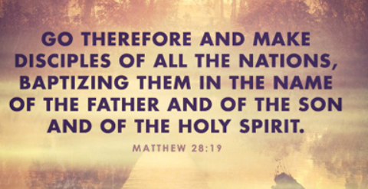
What should we be able to do?
Describe how Jesus’ words about salt and light influence a Christian.
Describe some things churches typically do as part of their mission to love God and love their neighbour.
Describe what a Christian believes about the Holy Spirit and how he empowers Christians to make a difference in the world.

Miracles like the feeding of the 5,000.
T
Thgehe

What words should we understand and be able to use?
Mission | Every Christian is called to worship God as part of a group of believers or church and to serve God in the world and make a difference. This is their mission. | Great Commission | When Jesus told his followers to go out into the world and share his message. Found in the Gospel of Matthew in the Bible.
Pentecost | A celebration of the coming of the Holy Spirit found the Bible in the book of Acts. | Marks of Mission | The Church of England has five marks of mission - TELL – TEACH – TEND – TRANSFORM – TREASURE.

