LKS2 How does believing Jesus is their saviour inspire Christians to save and serve others?
Prior learning: Christians are followers of Jesus, the saviour of the world. He died but came back to life.
A cross reminds Christians of his sacrifice, but is also a sign of commitment and God’s love.
Jesus told parables to teach about God’s Kingdom and the right way to live.
Christians pray to God and worship him in different ways. God offers us forgiveness.
The Holy Spirit reminds Christians God is always with them.

What should we know?
Remember people were amazed at what Jesus said and did when he was alive.
Christians believe:
- Jesus was a rescuer or saviour (the name Jesus means saviour).
- The Bible tells us stories of when Jesus saved people when he was alive. He also saved us all through his death.
- Humans are made in God’s image. However, when we disobey God’s rules or fail to live up to them, we are ‘spoilt’.
- In serving others by making a difference in response to Jesus saving them.

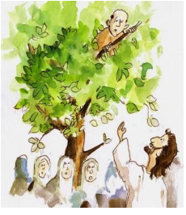
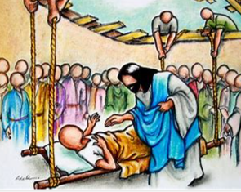
What should we be able to do?
Describe some different ways that Christians show their beliefs about Jesus in Christmas carols or on Christmas cards.
Describe some things Christians do as part of their faith to try to ‘save’ or help others, some the same, some different.
Understand who Christians believe Jesus to be - the saviour of the world.

Zacchaeus changed when he was ‘saved.’

Jesus healed the sick.

Miracles like the feeding of the 5,000.
T
Thgehe
Who cares?

What words should we understand and be able to use?
William Booth | Founder of the Salvation Army. | Sin | We are made in God’s image, but are no longer perfect. Sin means we fall short of who we were meant to be.
Salvation Army | A Christian church. Those who attend put their faith into action by helping the vulnerable.

