LKS2 What difference did Paul’s conversion on the Damascus road make to Christians?
What should we know?
Conversion is about change.
Before his conversion, Paul thought Christians needed to stop spreading lies that Jesus was God’s Son.
After his conversion, Paul became a follower of Jesus. He travelled around the world to tell people the good news about Jesus. His purpose in life changed.
Christians believe:
- Paul persecuted Christians then became one.
- Paul wrote to those he helped become Christians. These letters are now in the New Testament and are read in churches; they provide guidance on Christian living.
- The Holy Spirit lives inside them and helps them to became more like Jesus.
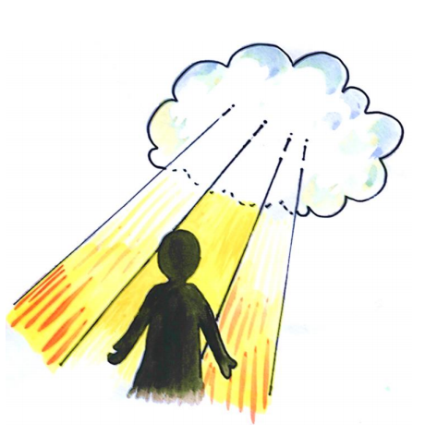

Like St Paul, some convert to Christianity quickly, and others more slowly. However, it always involves change which the Holy Spirit aids.
What should we be able to do?
Describe what Christians might learn from the story of St Paul’s conversion about what God is like.
Retell the story of Paul’s conversion.
Describe how Christians read Paul’s letters in church to guide their way of life.
Explain that the Holy Spirit helps Christians become more like Jesus.
In KS1: Christians are followers of Jesus, the saviour of the world. He died at Easter but came back to life.
Jesus told parables to teach about God.
Christians pray to God and worship him in different ways.
The Holy Spirit reminds Christians God is always with them.

T
Thgehe

What words should we understand and be able to use?
Missionaries | Missionaries preach the Christian gospel. | Philippi | An ancient city close to Greece.
Persecuted | Being badly treated. | New Testament | The second part of the Bible recording the life of Jesus and the teachings of the early church.

