KS1 Why is belonging to God and the church family important to Christians?
In EYFS, Christians believe:
God is a VIP and Jesus, his son, was a very special baby.
Jesus died on a cross.
Everyone, and our world, is precious to God.

What should we know?
Christians believe:
- They are part of a church family.
- Christening / baptism is a special welcome into the Christian family.
- Presents are given to help the baby grow up as a Christian.
- It is important to welcome people to church because Jesus always welcomed people.
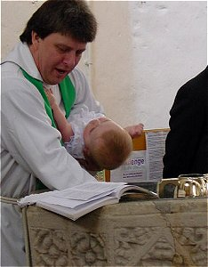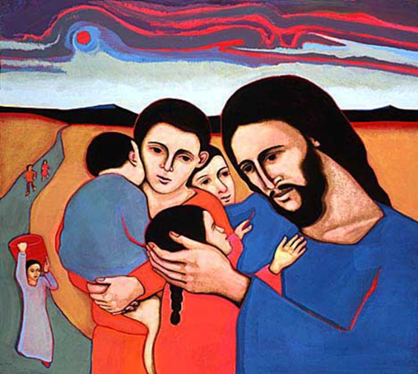
What should we be able to do?
Recognise that a baby being baptised is part of the Christian religion.
Remember something that happened when children came to see Jesus.
Name some items used at a baptism (candle, shell, water).

What words should we understand and be able to use?
Baptism and Christening | When someone is officially welcomed into the Christian family. | Christian | Someone who follows Jesus.

