**KS1 Why is the Torah such a joy for the Jewish Community?**

**What should we know?**

The Torah is an important book for Jews.

Jewish people believe:

* The Torah is a very important book, so important, that when they get to the end, they start to read it all over again.
* The Torah was given to the Jewish people from God.
* The Torah contains rules from God on how we should live.
* The Torah should be treated with respect.

**Prior**

**learning**

Jewish people believe good deeds like helping others are important.

Jewish people say prayers and blessings to God.

Shabbat is a day of rest.

At New Year God gives people a chance to put things right.

**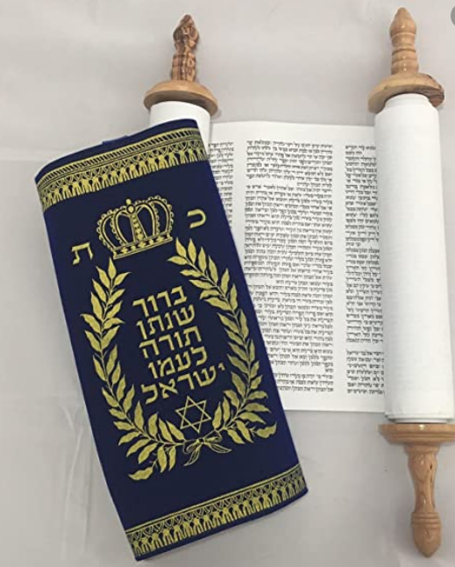

**What should we be able to do?**

*Describe how the Torah is used in the synagogue.*

*Recall some of the stories of Moses e.g. 10 commandments or the birth of Moses.*

*Say that the Torah is kept in a synagogue or in a special ark.*

*Know the Torah contains rules.*

*Demonstrate how a mezuzah is used by Jewish people.*

The Torah – an important book containing God’s rules.

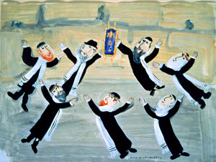

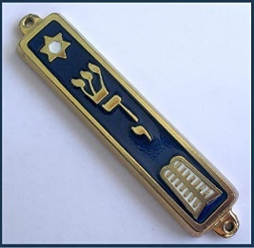

**What words should we understand and be able to use?**

|  |  |  |  |
| --- | --- | --- | --- |
| **Simchat Torah** | A joyous holiday that celebrates the Jewish love of Torah. It marks the end of the annual cycle of weekly Torah readings and the beginning of the new cycle. | **Mezuzah** | A decorative case fixed to the entrance of a Jewish home containing some of the Torah which reminds people to love God and follow his commandments. |
| **Torah** | A very important book for all Jews containing God’s rules. | **Moses** | A great leader and teacher of Jewish history. |
| **Bimah** | Where the Torah scroll is placed ready for reading. | **Holy Ark (Aron Kodesh)** | The cupboard where the Torah scrolls are kept in a synagogue. |
| **Synagogue** | The Jewish place of prayer and study. | **Hebrew** | The language of the Torah. |