LKS2 Why do Muslims call Muhammad the ‘Seal of the Prophets’?
What should we know?
A prophet is chosen by God and provides guidance in the form of a good example to follow. Muslims believe:
- Allah has sent many messengers into the world to call people back to him when they have behaved badly.
- Muhammad was chosen by Allah to be his final prophet.
- Muhammad is greatly respected by Muslims but he is not to be worshipped.
- Muhammad told people to submit to Allah and to worship no-one else.

What should we be able to do?
Explain that Muslims believe Muhammad was a messenger of God and the last prophet and recall something about his life.
Describe the Shahadah and know all Muslims everywhere recite the same words.
Describe what Muslims might learn from a story about Muhammad’s life.
Describe some different ways Muslims show their beliefs about Muhammad such as in art, calligraphy or design.
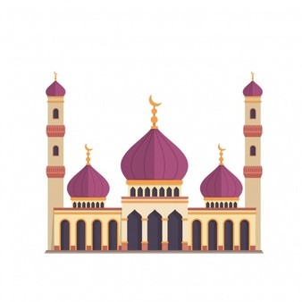
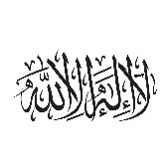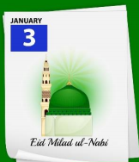
Prior
learning
Muslims believe Allah is the one true God and should be obeyed in every way.
Muslims trust him to tell them the right thing to do.
Praying five times a day helps them to remember to submit to Allah in all they do.

Finding evidence of Muhammad in a mosque.

Celebrating Muhammad’s birthday.

There is no God but Allah and Muhammad is the messenger of God.

What words should we understand and be able to use?
Prophet | Someone chosen by God to deliver a message. Muslims believe Allah sent thousands of prophets, but Muhammad was the last one. | Muhammad | Allah’s final prophet.
Mosque | A Muslim place of prayer where Muslims submit themselves to Allah. It is also a community centre and place of study. | Shahadah | The Muslim profession of faith (‘there is no god but Allah, and Muhammad is the messenger of Allah’)

