**God’s Family Goes**

*Before we go we say what we believe in an East African Masai creed:*

We believe in the one High God, who out of love created the beautiful world and everything good in it. He created man and wanted man to be happy in the world. God loves the world and every nation and tribe on the Earth.

**This we believe.**

We have known this High God in darkness, and now we know Him in the light. God promised in the book of His word, the Bible, that He would save the world and all the nations and tribes.

**This we believe.**

We believe that God made good His promise by sending His Son, Jesus Christ, a man in the flesh, a Jew by tribe, born poor in a little village, who left His home and was always on safari doing good, curing people by the power of God, teaching about God and man, showing the meaning of religion is love.

**This we believe.**

He was rejected by his people, tortured and nailed hands and feet to a cross, and died. He lay buried in the grave, but the hyenas did not touch him, and on the third day, He rose from the grave. He ascended to the skies.   
He is the Lord.

**This we believe**.

We believe that all our sins are forgiven through Him. All who have faith in Him must be sorry for their sins, be baptized in the Holy Spirit of God, live the rules of love and share the bread together in love, to announce the Good News to others until Jesus comes again.

**We are waiting for Him. He is alive. He lives. This we believe. Amen.**

*We say together a final prayer :*

**Holy Spirit of the Living God be with us and with our friends in our link diocese of Kagera. Fill us all with your love and power, and give us the grace to work together to build your kingdom, that all might have life in its fullness.** **Amen.**

*The leader will give us God’s blessing before we go.*

*We stand to sing a SONG during which a collection will be taken for the Bishops' Lent Appeal.*

**family@church/kagera**

**Welcome to our Family Worship for Kagera.**

**Please make yourselves at home in this**

**beautiful church.**

If children cry or become restless, please don’t leave the church; stay inside and feel free to move around or visit the children’s area. There is also a toilet at the back of the church.

**God’s Family Gathers**

*Before the service starts, a brief welcome is given and an introduction to Kagera and the Bishops’ Lent Appeal.*

Christ came into this world

**All: So that everyone would have life and have it fully.**

*(John 10:10)*

*Opening prayer:*

Loving God, we have come to worship you.

**Help us to pray to you in faith,**

**to sing your praise with gratitude,**

**and to listen to your word with eagerness;**

**through Christ our Lord. Amen.**

*We greet one another and then share family news.*

*What has happened to you this month that you’d like to share?*

*We stand to sing a SONG.*

*We all probably got some things wrong this month, so now it is time to say sorry to God, so we can ‘clear the air’ before we begin our worship.   
To remind us of our theme, the responses are in Swahili, the national language of Tanzania. They are easy to say – give it a go!*

Dear God, we are sorry when we are not the people you would like us to be.

Bwana uturehemu (Lord have mercy)

**Bwana uturehemu**

We are sorry when we try to live all by ourselves, instead of talking to you and with other people who love us.

Kristo uturehemu (Christ have mercy)

**Kristo uturehemu**

We are sorry when we push away other people who need us to listen to their worries and to support them in their lives.

Bwana uturehemu

**Bwana uturehemu**

Christ came into the world to forgive people just like us.

May the God of Love bring us back to himself, forgive us our sins and assure us of His eternal love, in Jesus Christ our Lord.

**Amen.**

*When we have heard God's forgiveness we stand to sing a SONG*

**God’s family listens**

*We hear God’s Word from the Bible being read:*

**Romans 12 4—11**

*At the end of the reading you may hear:*

This is the Word of the Lord

**All: Thanks be to God!**

*Someone will give us a talk to help us understand God’s Word.*

*After we have heard God’s Word, we stand to sing a SONG*

**God’s family prays**

*At this special service our prayers are all about our link diocese of Kagera*

*When we have prayed together we say the Lord’s Prayer*

**All: Our Father in heaven, hallowed be your name.**

**Your kingdom come, your will be done,**

**on Earth as in heaven.**

**Give us today our daily bread.**

**Forgive us our sins,**

**as we forgive those who sin against us.**

**Lead us not into temptation,**

**but deliver us from evil.**

**For the kingdom, the power and the glory are**

**yours, now and for ever. Amen**

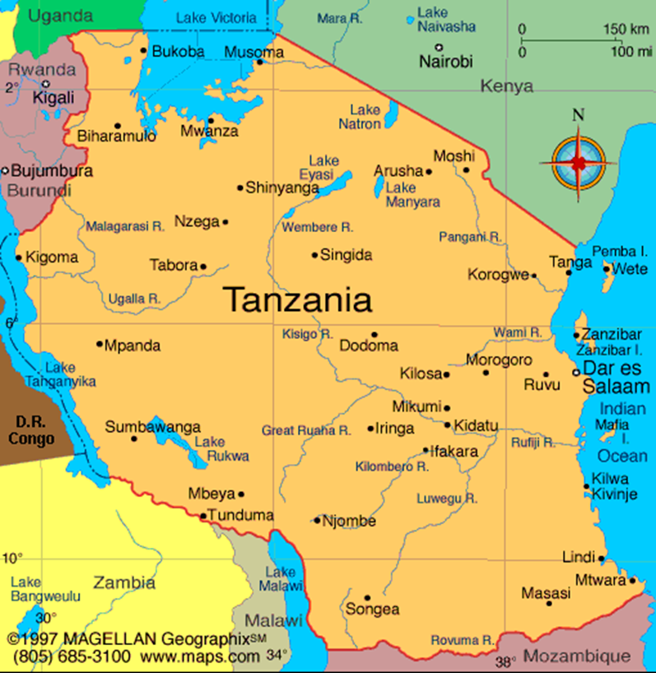

Kagera Christian

Training College

Ngara Anglican

Primary School

Pastors and

their families

Church and Community

Mobilisation Process

