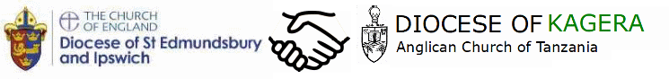
Holy Communion Service
celebrating our link with
the Diocese of Kagera, Tanzania

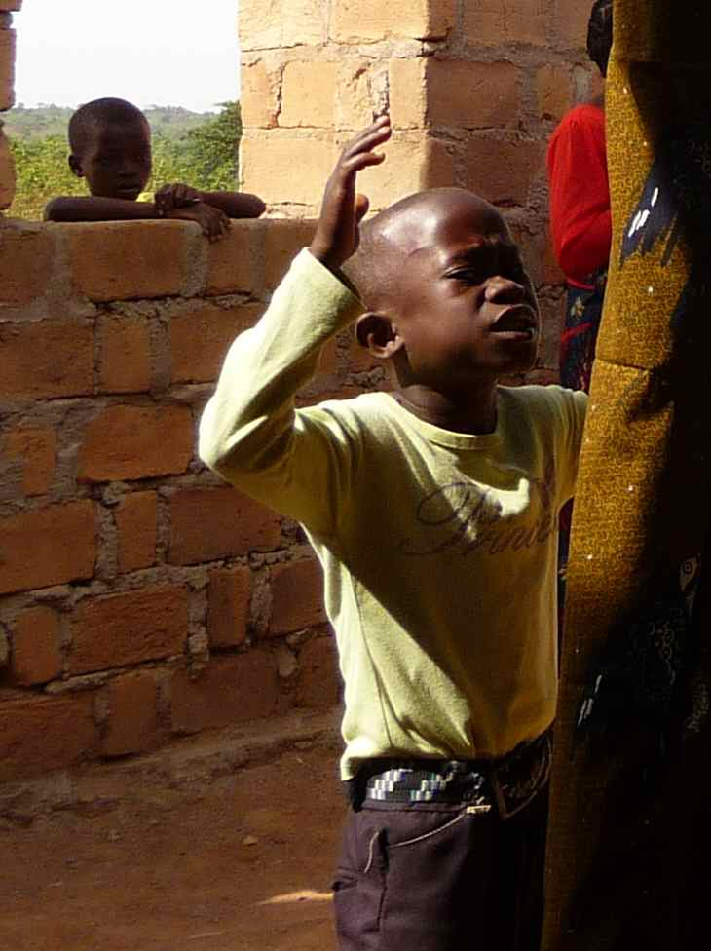

Our service today celebrates and supports our link Diocese of Kagera in north west Tanzania.

Some parts of the service include words and phrases in the lational language of Kiswahili – it is entirely phonetic, so give it a go.

Please join in the responses in bold

KARIBUNI - WELCOME

Kwa jina la Bwana,  na Mwana,  na Roho Mtakatifu.  Amina | In the name of the Father,  and of the Son  and the Holy Spirit  Amen
Bwana akae nanyi  Pia na roho yako |  | The Lord be with you  And with your spirit

Almighty God,
to whom all hearts are open,
all desires known,
and from whom no secrets are hidden:
cleanse the thoughts of our hearts
by the inspiration of your Holy Spirit,
that we may perfectly love you,
and worthily magnify your holy name;
through Christ our Lord.
Amen.
Confession
As we come to worship, let us confess our forgetfulness of the needs of others, and our neglect of God's law, to love God and to love our neighbour as ourselves.

Dear God, we are sorry when we are not the people
you would like us to be.
Bwana uturehemu (Lord have mercy)
Bwana uturehemu

We are sorry when we try to live all by ourselves,
instead of talking to you
and with other people who love us.
Kristo uturehemu (Christ have mercy)
Kristo uturehemu

We are sorry when we push away other people
who need us to listen to their worries
and to support them in their lives.
Bwana uturehemu
Bwana uturehemu

Christ came into the world to forgive people just like us.
May the God of love bring us back to himself,
forgive us our sins and assure us of his eternal love,
in Jesus Christ out Lord.
Amen

The Collect

Readings
At the end of each reading the reader may say:

Bwana asifiwe  Amina | Praise the Lord  Amen
Sermon

An East African Masai Creed
We believe in the one High God, who out of love created the beautiful world and everything good in it. He created Man and wanted Man to be happy in the world. God loves the world and every nation and tribe on the Earth.
This we believe.
We have known this High God in darkness, and now we know Him in the light. God promised in the book of His word, the Bible, that He would save the world and all the nations and tribes.
This we believe.
We believe that God made good His promise by sending His Son, Jesus Christ, a man in the flesh, a Jew by tribe, born poor in a little village, who left His home and was always on safari doing good, curing people by the power of God, teaching about God and man, showing the meaning of religion is love.
This we believe.
He was rejected by his people, tortured and nailed hands and feet to a cross, and died. He lay buried in the grave, but the hyenas did not touch him, and on the third day, He rose from the grave. He ascended to the skies. He is the Lord.
This we believe.
We believe that all our sins are forgiven through Him. All who have faith in Him must be sorry for their sins, be baptized in the Holy Spirit of God, live the rules of love and share the bread together in love, to announce the Good News to others until Jesus comes again.
We are waiting for Him. He is alive. He lives. This we believe. Amen.
Prayers of Intercession

As we grow in God together, we pray for our brothers and sisters in Christ around the world, and especially for the people of Kagera. Many miles separate us but your grace and spirit unites us in hope and prayer.
In our world of plenty we bring to you the needs of a nation who lack the resources so easily available to us. In the face of climate change we pray that improved agriculture will bring fruitful harvests. Let us learn not to take for granted all that we have and to give willingly to others less fortunate than ourselves.
Lord in your mercy … Hear our prayer

As we grow in God together, we give thanks for the support given in this Diocese for Kagera.
We pray for your blessing on the work of pastors and church leaders, here and in Kagera as they mobilise and lead their communities, teaching them and guiding them on the path to a better life in this world and the next.
Lord in your mercy … Hear our prayer

As we grow in God together, we bring to you the spirit of Kagera in all its colour and richness of culture. We give thanks for the people of Kagera and their commitment to each other and their church; for their willingness to give with generosity when they have so little; and their appreciation for the life that they have.

In a country where we seem to have so much, may we re-learn from Kagera the spirit of humility and gratitude, and reconsider our attitude to wealth and material possessions.
Lord in your mercy … Hear our prayer

Dear Lord, as we unite in growth, we offer these prayers for ourselves and for our link diocese, through Jesus Christ our Lord. Amen
The Peace

Amani ya Bwana  ikae nanyi daima | The Peace of the Lord  be with you always
Pia na roho yako | And with your spirit

The congregation offer one another a sign of peace, each saying Amani (Peace)

Communion prayer

The Lord be with you
and also with you

Lift up your hearts
We lift them to the Lord

Let us give thanks to the Lord our God
It is right to give thanks and praise.

We give you thanks and praise, Father,
because you have made us part of your family,
a family of children from every nation, language and tribe.
We thank you that we are one with our brothers and sisters in Kagera.
We pray for them as they pray for us, and commit ourselves to you
as we strive afresh to work for justice in your world.
When the rains fail, Lord, stir us to pray;
When the harvest is poor, Lord, stir us to act.
When faith is difficult, Lord, may we be examples to each other of your truth.

Guide your Church in every land,
and in this feast of bread and wine
may we be made one in the bond of the Spirit.

You sent Jesus, your Son, to make the whole of humanity one,
by preaching and praying a message of unity and love,
dying on the cross, rising again for us,
and living for us now at your right hand.
Therefore, with angels and archangels
we join with our brothers and sisters in Kagera,
Christians throughout the world and the whole company of heaven,
in the song that resounds throughout the world:

Holy, holy, holy Lord,
God of power and might,
heaven and earth are full of your glory.
Hosanna in the highest.
Blessed is he who comes in the name of the Lord.
Hosanna in the highest.

Please sit or kneel
Father, on the night before he died,
Jesus shared a meal with his friends.
He took the bread, and thanked you.
He broke it, and gave it to them, saying:
Take and eat; this is my body, given for you.
Do this to remember me.

After the meal, Jesus took the cup of wine.
He thanked you, and gave it to them, saying:
Drink this, all of you.
This is my blood,
the new promise of God's unfailing love.
Do this to remember me.

Great is the mystery of faith
Christ has died:
Christ is risen:
Christ will come again

Father, as we bring this bread and wine,
and remember his death and resurrection,
send your Holy Spirit,
that we who share these gifts
may be fed by Christ's body and his blood.

Pour your Spirit on us
that we may love one another,
work for the healing of the earth,
and share the good news of Jesus,
as we wait for his coming in glory.
For honour and praise belong to you, Father
with Jesus your Son, and the Holy Spirit:
one God, for ever and ever. Amen

Our Father in heaven,
hallowed be your name,
your kingdom come,
your will be done,
on earth as in heaven.
Give us today our daily broad.
Forgive us our sins
as we forgive those who sin against us.
Lead us not into temptation
but deliver us from evil.
For the kingdom, the power,
and the glory are yours
now and for ever. Amen

Draw near with faith.
Receive the body of our Lord Jesus Christ
which he gave for you
and his blood which he shed for you.
Eat and drink
in remembrance that he died for you,
and feed on him in your hearts
by faith with thanksgiving.
Most merciful Lord,
your love compels us to come in.
Our hands were unclean,
our hearts were unprepared;
we were not ﬁt
even to eat the crumbs from under your table.
But you, Lord, are the God of our salvation,
and share your bread with sinners.
So cleanse and feed us
with the precious body and blood of your Son,
that he may live in us and we in him;
and that we, with the whole company of Christ,
may sit and eat in your kingdom.
Amen

The congregation receive communion at the altar rail. All are welcome for communion or a blessing. To receive a blessing, please keep your hands below the altar rail

Prayer after communion

Almighty God
We thank you for feeding us
with the body and blood of your Son Jesus Chris
Through him we offer you our souls and bodies
to be a living sacrifice
Send us out in the power of your spirit
to live and work to you praise and glory. Amen

Blessing

Go in peace to love and serve the Lord
Tumshukuru Mungu (Thanks be to God)

