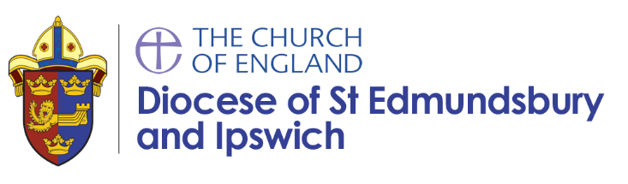

Self-Supporting Ministers

Self-supporting ministers are called by God to be sacramental clergy within the Church of England. They are trained to the same standard as any other clergy, and their main duties are broadly similar to stipendiary clergy: to reconcile the divided, heal the broken, and restore the lost, but they choose to exercise their ministry without being paid a stipend.

For some of them this means that their parish is their place of work, for others it is where they live.

Most work in teams, and some are a focal minister for one particular community, or as a sector minister for one particular type of ministry. Some of them are licensed just to a particular benefice or deanery while others are deployable by the Bishop wherever their skills might be needed most.

Many of them cherish the ability to work out their calling within a secular work environment, or to use the freedom of a reduced parochial commitment to develop ministries in other ways.

All SSMs serve under the terms of a work agreement, which defines their responsibilities and time commitment, often limited to two days a week. They all work within the accountability structures of the parish and diocese.

Mike Birt – SSM

I have been a Christian since the early 1980s. I worked for 35-years with the Metropolitan Police in a civilian management role and was much involved with the Christian Police Association in London before taking retirement.
I moved to Suffolk and trained for three years with the Eastern Region Ministry Course (ERMC). I was appointed to serve as a part-time SSM in my local Benefice of Woolpit and Drinkstone. I also work as a member of the St Nicholas Hospice Chaplaincy Team in Bury St Edmunds.
I have always enjoyed engaging with people and the local community and my appointment has enabled me to expand the privilege of serving others in a variety of church and secular settings together with learning more about myself and the love of God through Jesus Christ for all people. My hobbies include tinkering with old cars when I get time!

How do I know if I am called?

Gods calling is both simple and complicated. It may start with a strong inner sense of being drawn to something, maybe not clearly defined at first, or by a dissatisfaction with what you are doing at the moment. Or someone who knows you well might encourage you to think about this.

This call needs to be tested by others, including your parish and incumbent, and then by the Diocesan Director of Ordinands and others, who will be able to help you work out precisely what you might be being called to. You may be asked to attend a national selection conference called a Bishop’s Advisory Panel.

What does the training look like?

There are different pathways. You might join a local training cohort and learn through study and discussion with others, or you might be encouraged to join a course and undertake formal study over a couple of years. For most, a course covering the basics of faith, biblical studies, ethics and pastoral care is probably a baseline, while for others a more academic approach to first or second degree level might be possible.

Deployable SSMs are expected to do a curacy away from their sending church, either by placements over an extended period of time, or more typically by a three-year period in a local church, to help you understand the breadth of the Church of England, and you will also need to commit yourself to continuing ministerial education for some years after ordination.

When would I be ordained?

When the Bishop thinks you are ready, The Bishop will ordain you first as deacon and all being well, in the following year you will be ordained priest.

What support would I get?

Training would be as part of a group of people probably from differing backgrounds but heading in the same direction. After ordination most SSMs work as members of a team, supporting and being supported by others.

For more information
If you are interested in becoming a SSM please talk to your local vicar or an existing SSM in your deanery.
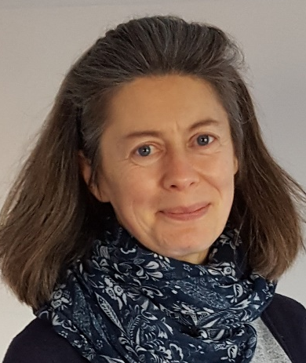
For general enquiries about new SSMs, their initial or ongoing training please contact:

Mrs Lesley Steed
Mission and Ministry Team Senior Administrator

lesley.steed@cofesuffolk.org
Phone: 01473 298510

Registering an interest or further enquiries please contact:

The Revd Tony Redman
Bishop's Advisor on Self Supporting Ministry

ssm.advisor@cofesuffolk.org
Phone: 01359 269335

Produced by Diocese of St Edmundsbury and Ipswich
Updated June 2018

