KS2 Why do humanists use the golden rule as a basis for morality?
What should we know?
Morality is about doing the right thing.
Humanists believe:
- Humans can be good without having a religious belief.
- We can think for ourselves about what is right or wrong.
- The Golden Rule and empathy make the world a better place for everyone.
- We should be guided by thinking about the consequences of our actions
- Stories are helpful for learning about the right thing to do

Throwi
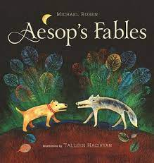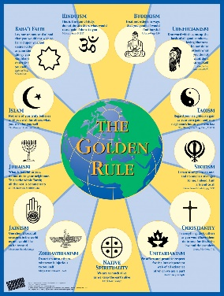

What should we be able to do?
Describe humanism as a non religious worldview
Describe how humanists make decisions about what is right
Recognise different forms of the Golden Rule in religions and cultures
Explain what empathy is and why Humanists consider it an important value
Understand that not everyone believes in God.

What words should we understand and be able to use?
Golden Rule | Do to others what you would have them do to you | Empathy | Standing in someone else’s shoes
Conscience | Your own sense of right or wrong | Morality | Knowing what is right or wrong, good or bad
Theist | Someone who believes in God | Atheist | Someone who does not believe in God
Agnostic | Someone who believes it is impossible to know for sure if God exists | Worldview | Your way of seeing and understanding the world

