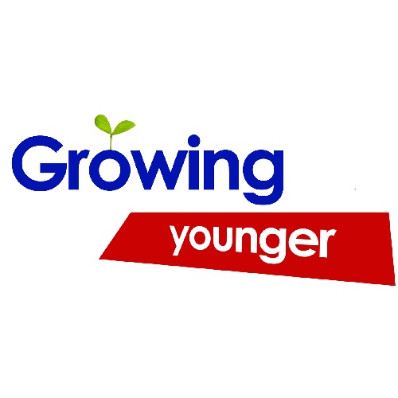
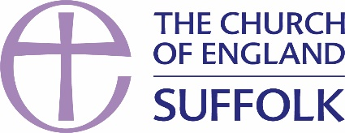

We aim to grow congregations and/or fresh expressions of church that match the age profile of the local population

Please indicate how much you agree with the following statements about your church or benefice (the higher the score, the more you agree)
Starter
 | People attend our services and activities from across the age range of the area we serve | 1 | 2 | 3 | 4
Statements
 | The predominant age range in our congregations reflects that of the local population | 1 | 2 | 3 | 4
 | We have dedicated activities for the age range between 25 and 65 | 1 | 2 | 3 | 4
 | We have a specific focus on under-fives, including our baptism families | 1 | 2 | 3 | 4
 | We have effective partnerships with our catchment primary school(s) | 1 | 2 | 3 | 4
 | We offer the children and families with whom we have contact life-enhancing encounters with Jesus Christ | 1 | 2 | 3 | 4
 | We have effective partnerships with our catchment secondary school(s) | 1 | 2 | 3 | 4
 | We offer each young person and their family life-enhancing encounters with Jesus Christ | 1 | 2 | 3 | 4
 | Our services are places of hospitality, creativity and celebration for under-18s | 1 | 2 | 3 | 4
 | We seek to engage with young adults (18-25s) | 1 | 2 | 3 | 4
 | People under 40 are represented on our decision-making bodies | 1 | 2 | 3 | 4
What is our learning from these questions?

What do we notice that is good/could be even better?

How may these things fit into our Plan For Growth?

Do you need help to Grow Younger? If so contact hilary.wordsworth-sewell@cofesuffolk.org (children and families) matt.levett@cofesuffolk.org (youth and young adults)

