LKS2 Why do Christians call themselves the ‘Body of Christ’?
What should we be able to do?
Use the word ‘church’ to reflect the Christian belief that it means both a building and Christian people.
Describe what a Christian might learn from St Paul’s writings about God and about living as part of the ‘Body of Christ.’
Describe some of things that Christians typically do as part of leading a church

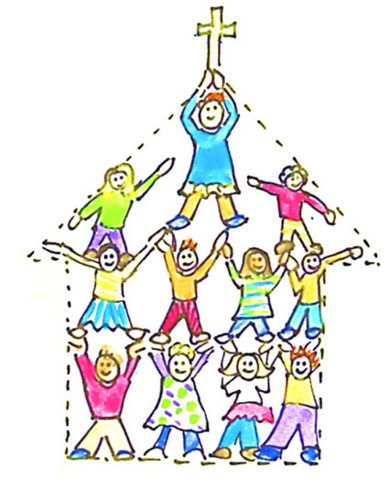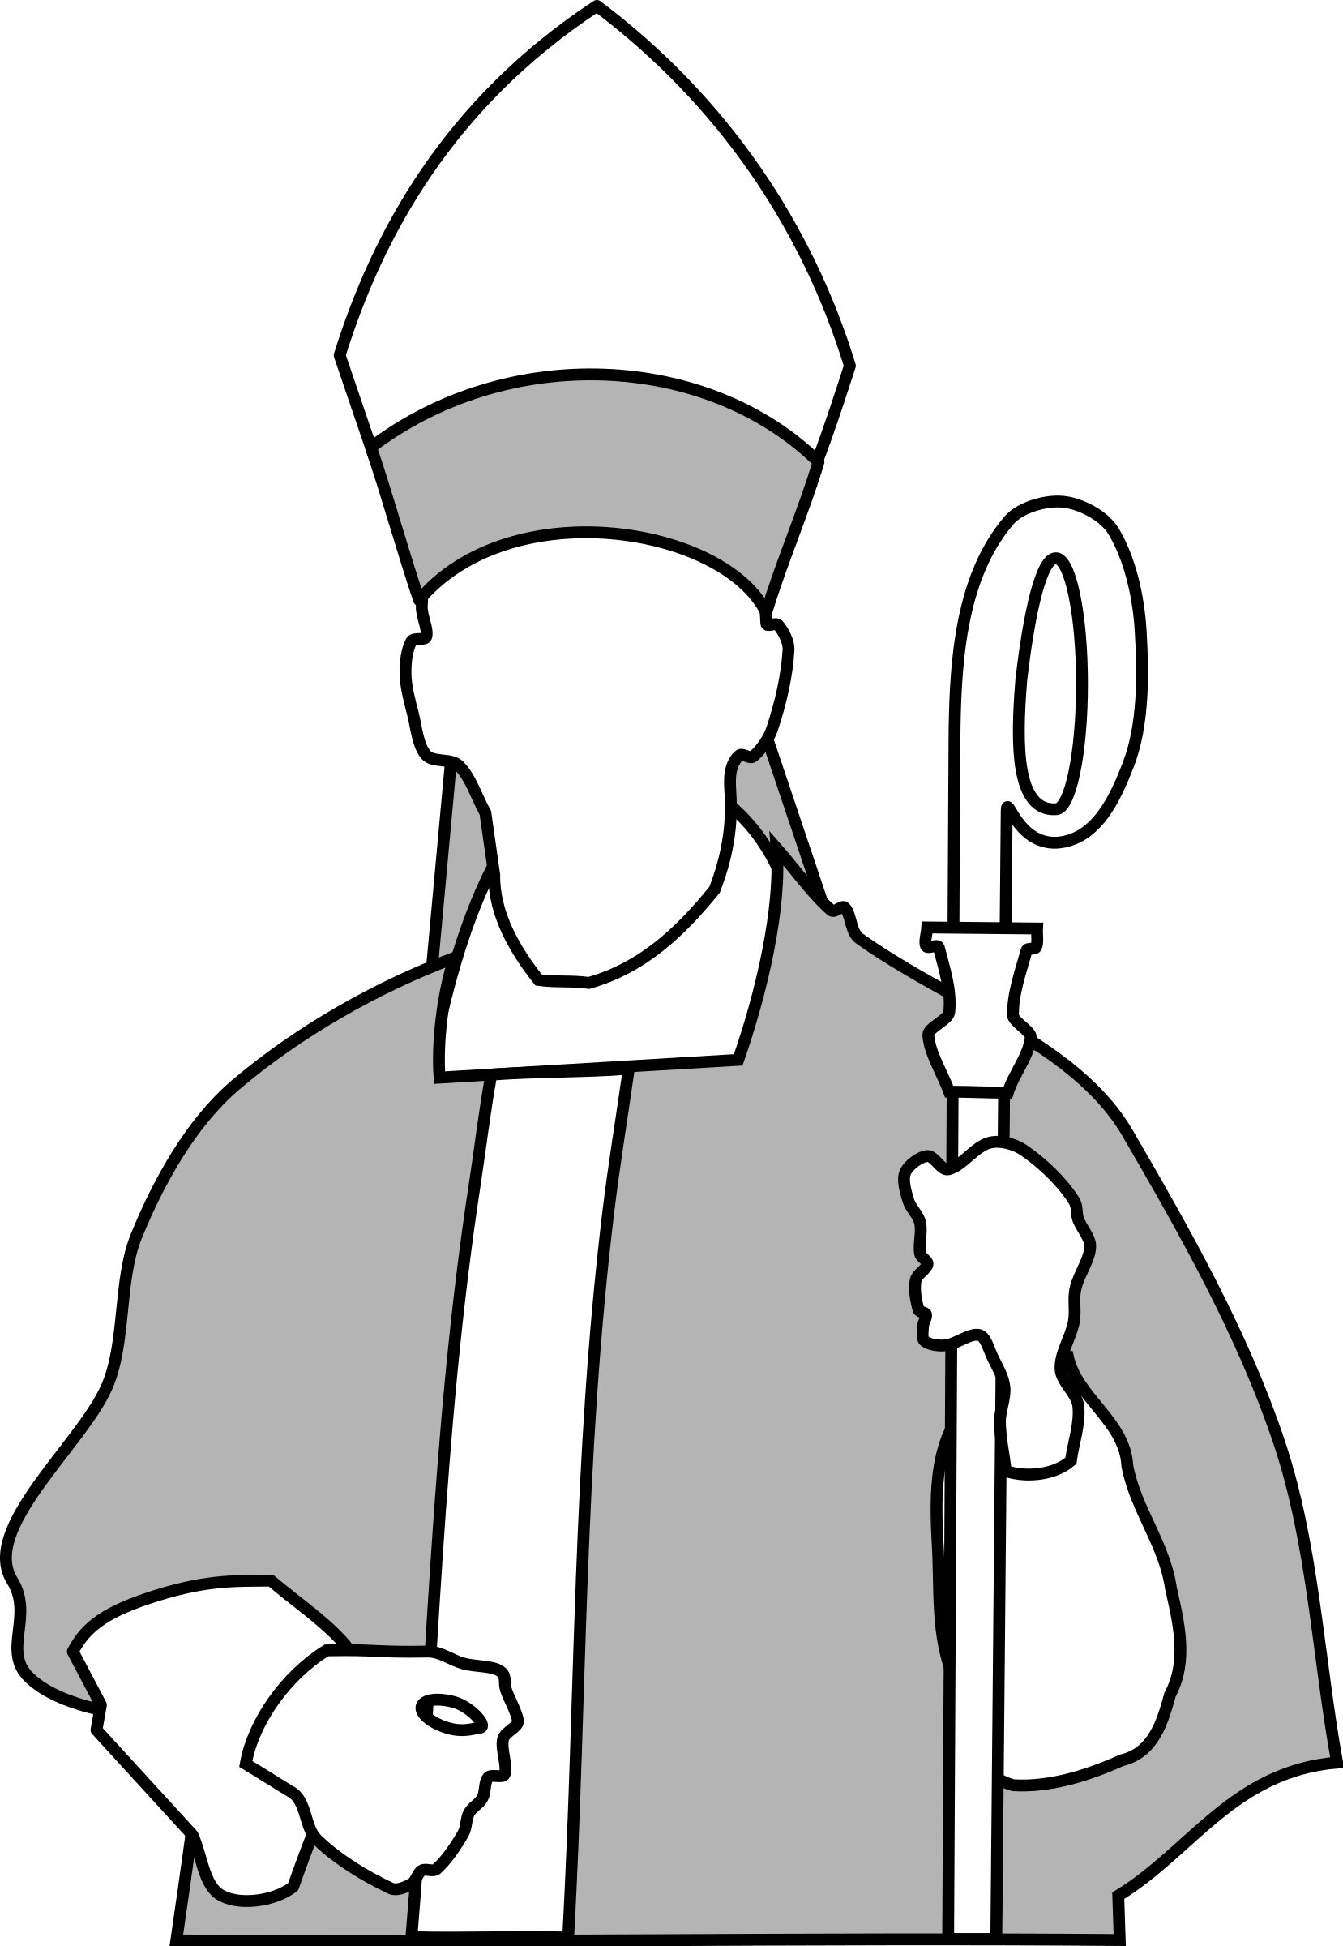

The Christian church is a body of people rather than a building. The church is a family of people all being the hands and feet of Jesus.

What should we know?
That the ‘Body of Christ’ is lots of people joined together like a body with Jesus Christ as the head. It is another name for the church.
That Christians believe:
- The Apostles spread Jesus’ message and many became followers. This is how the early church began.
- Individual churches across the world may be different, but Jesus is the head of every Christian church.
- God calls us to work for him, but we are not on our own. We are part of the Body of Christ. We are God’s body on earth making a difference to those around us.
In KS1:Christians are followers of Jesus, the saviour of the world. He died at Easter but came back to life.
Jesus told parables to teach about God.
Christians pray to God and worship him in different ways.
The Holy Spirit reminds Christians God is always with them.

T
Thgehe

What words should we understand and be able to use?
Disciple | A follower of Jesus. | Apostle | ‘Apostle’ means ‘one sent out’. Jesus gave his 12 disciples this title; he trained them to take on his ministry.
Deacon | Deacon means servant. Many churches have deacons who look after some aspect of church life. | Archdeacon | In the Anglican church, an archdeacon serves by taking responsibility for church buildings and the pastoral care of clergy.
Bishop | A senior member of the Christian clergy, usually in charge of a diocese (region of church parishes). Traditionally they wear purple and carry a mitre and crozier. The mitre is a pointed hat said to represent the flames of the Holy Spirit at Pentecost and the crozier symbolises a shepherd’s crook.

