**KS1 Why do Jewish families talk about repentance at New Year?**

**What should we know?**

**Repentance** means saying sorry to God for bad deeds and making sure they don’t happen again.

Jewish people believe:

* God weighs the good and bad things we have done at New Year and gives people a chance to put things right.
* God forgives those who repent.

**Prior**

**learning**

Jewish people believe good deeds like helping others are important.

Jewish people say prayers and blessings to God.

Shabbat is a day of rest.

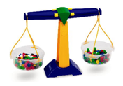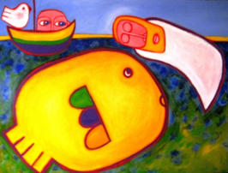**

**What should we be able to do?**

*Retell the story of Jonah.*

*Explain that for Jewish people new year is about saying sorry and making changes.*

*Describe what happens in a synagogue at Yom Kippur.*

The story of Jonah.

God says, “No matter if you have failed before; you can still return to me.”

**What words should we understand and be able to use?**

|  |  |  |  |
| --- | --- | --- | --- |
| **Rosh Hashanah** | the Jewish New Year. | **Yom Kippur** | The ‘day of atonement’ when Jews repent. |
| **Shofar** | Blown on Rosh Hashanah to start calling people to think about the wrong things they have done and put them right. It is then blown every day for ten days until the very special day of Yom Kippur. |  |  |