LKS2 Why does a Hindu want to collect good karma?
Sacred thread ceremony
Like climbing a ladder. Good choices have good results.
Ghandi - an inspiration to many Hindus.
Like buying and putting on new clothes – karma affects which clothes.
What should we be able to do?
Explain how snakes and ladders links with the idea of karma. That good choices have good results.
Begin to describe what Hindus might learn from one of their stories about living the right way.
Know that Hindus are encouraged to perform acts of selfless kindness.
Talk about how karma influenced Ghandi.
Know that even Hindu children must learn to take responsibility for gathering good karma.
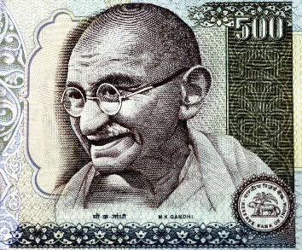
What should we know?
Karma means actions. Whatever we do produces a result.
Hindus believe
- We all have a soul.

- The soul is reincarnated when we die, it lives on and moves into a new body.

- We collect good and bad karma through our actions which always have consequences.

- Hindus are encouraged in their holy books to perform acts of selfless kindness.

What words should we understand and be able to use?
Hinduism | The name of a religion which started in India. | Samsara | The cycle of birth and death.
Hindu | Followers of Hinduism are called Hindus. | Reincarnation | After death the soul lives on and moves into a new body. Every human being has had many past lives.
Karma | Actions. What we do produces a result. | Soul | The spiritual part of a human being. The ‘real self.’
Moksha | Breaking free from the cycle of reincarnation and the soul being one with God.

