[insert name] Deanery
Mission and Pastoral Planning

Benefice Planning Tool

Benefice:

Owner/Contact:

Date last reviewed:

“I planted, Apollos watered, but God gave the growth" (1 Corinthians 3:6)

Deanery Planning Process

Purpose

The purpose of this planning process is to:

- Enable parishes and benefices to contribute to Mission and Pastoral Planning.
- Provide a framework within which activities can be identified and aligned with Growing in God.
- Provide a flexible common approach that informs the dioceses strategic thinking and planning.
- Provide a body to consolidate benefice plans, to ensure that progress of each deanery’s planning towards its objectives is reported annually to the deanery synod, and to modify the plan in the light of learning and experience.

Procedure

Adopted Deanery Plans are provided annually to the relevant Archdeaconry Mission and Pastoral Committee who report on them to the Diocesan Mission and Pastoral Committee (as part of the Bishop’s Council). Plans may be referred to, and reviewed by, the Bishop’s Staff and/or its Strategy Group at any time to enable the dioceses overarching strategic planning.

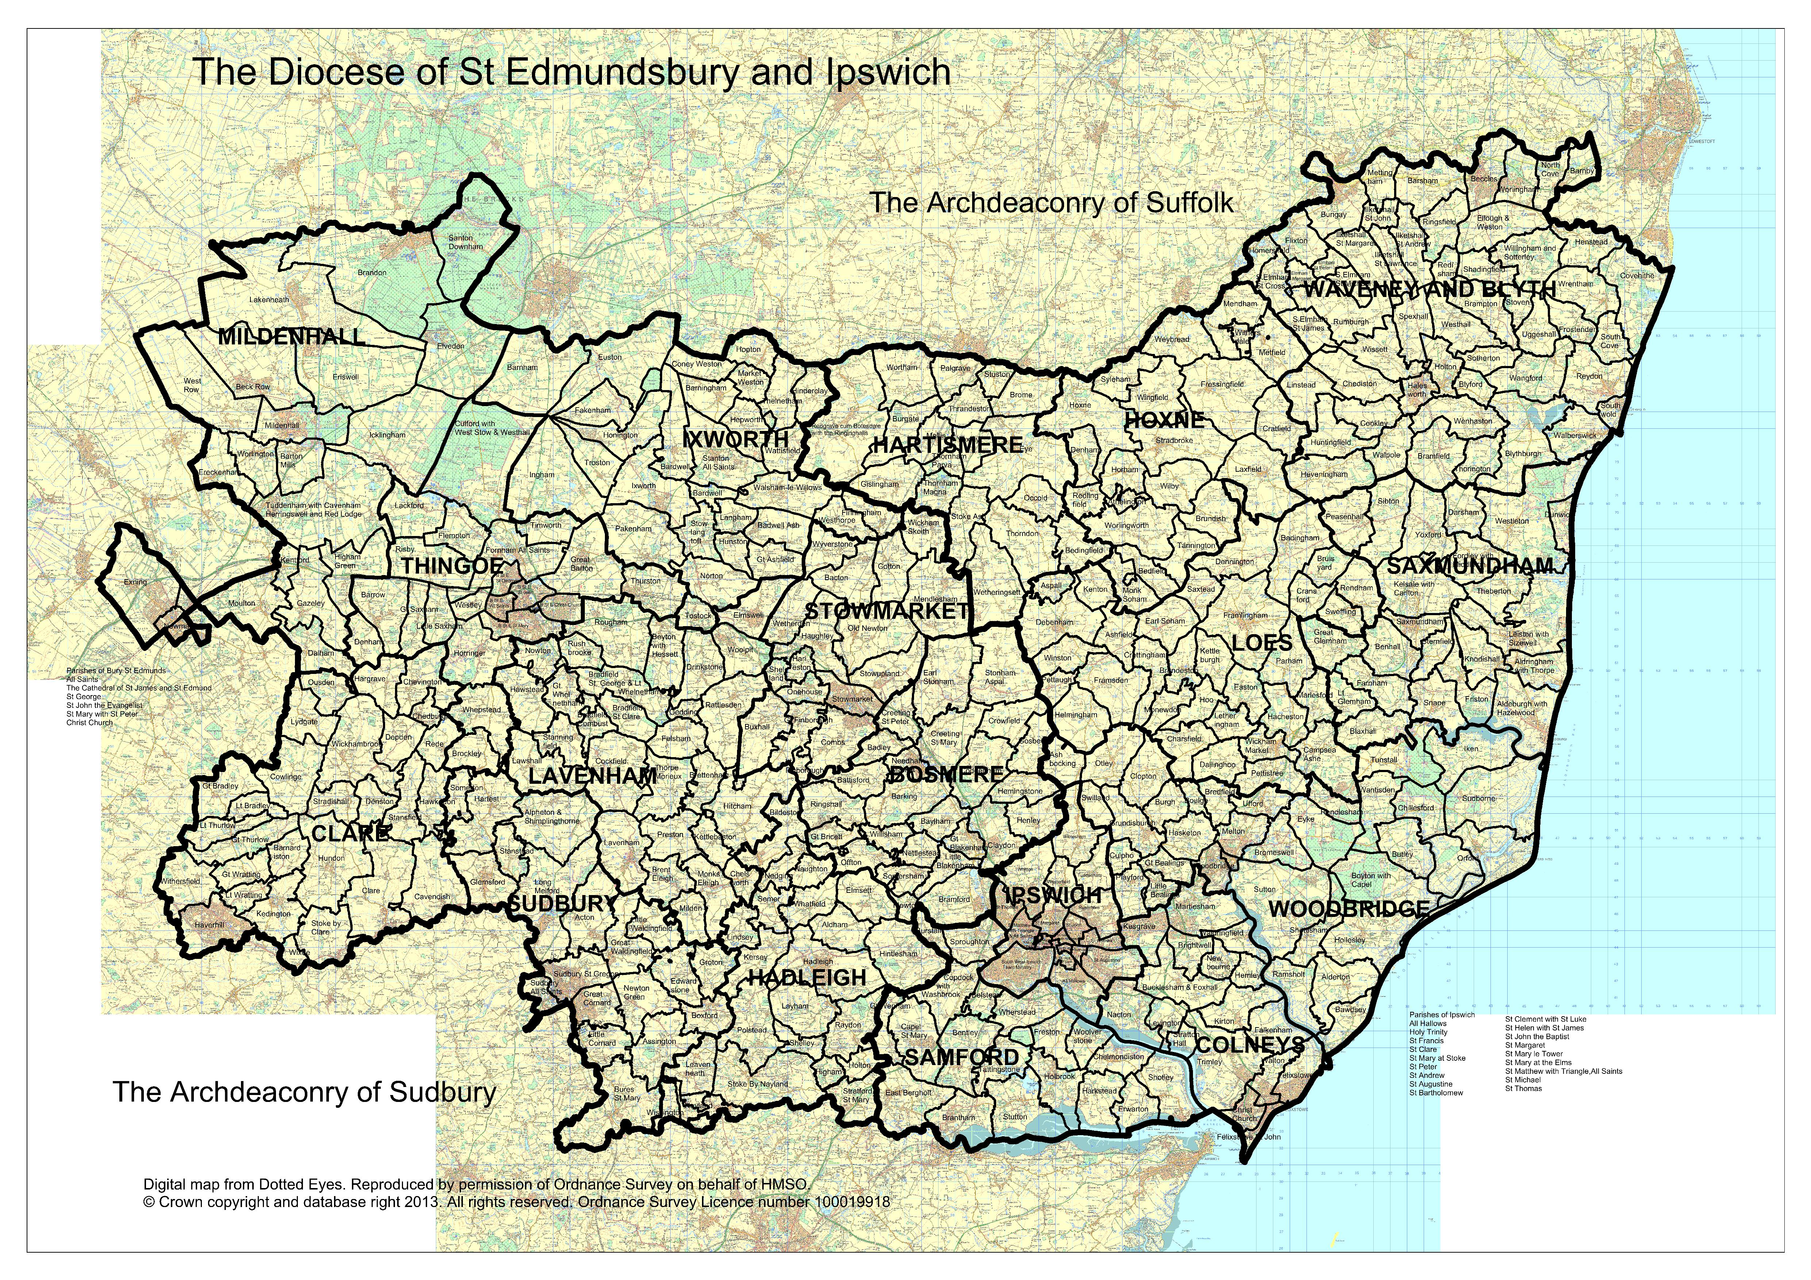

Deanery Map of Benefices

[insert map of relevant deanery here]

Benefice Audit

Parish officers (Churchwardens, Treasurers and PCC Secretaries) will have already researched and compiled some of this data for other purposes, like Statistics for Mission, Finance Return and Electoral Roll. If you do not have a copy, it is still accessible, links below with other useful data resources:

- Parish Spotlights: http://www.cofesuffolk.org/mission/parish-spotlights
- Parish Dashboards: http://www.cofesuffolk.org/mission/parish-dashboards
- National Church online parish return system: https://parishreturns.churchofengland.org/
  - accessible to parish data administrators
  - benefice level reporting available

Where there may be multiple measures for some categories (e.g. attendance, giving) those requested correlate to the diocesan key measures used to track the outputs and outcomes of the vision to Grow in God.

Existing Resources

Physical

ITEM | NUMBER and/or NAME(S)
Parishes
Parishes included above that are in the top 20% for deprivation
Ecclesiastical buildings
Other buildings (e.g. parish halls, church rooms, youth centres)
Church schools
Other schools

Colleges and university campuses
Hospitals and care homes
Average Weekly Attendance
Average weekly planned giving
Gift Aid claimed as % on annual, regular offerings
Parish Giving Scheme
- Number of parishes that are members?
- Number of parishioners that are donors?

People

The same person may appear in more than one category, please count them each time.

Stipendiary clergy – number of ‘established’ posts
Self-supporting clergy
Clergy with PTO
Pioneer ministers (no. of Lay /Ordained– including those counted above)
Readers
Chaplains (both Anglican and ecumenical appointments)
Ministers in Secular Employment
Lay Elders
Other accredited lay ministers
Healing prayer ministry
Spiritual accompaniers
Youth workers⁷
People in house Bible groups
People in house Prayer groups
Local Giving Advisers
Churchwardens
Deputy/Alternate Churchwardens
Number of parishes with administrators
PCC Secretaries
PCC Treasurers
Electoral Roll number
Population
Others (please list)
Other denominations within the parish (list)

Learning from our Statistics

What key strengths do we have? | 1.  2.  3.

What needs do we have?

What opportunities are there? *

What do the statistics show?

*Possible Considerations

- Boundary Changes (internal or external)
- New Housing
- Schools

Fabric and Forward Planning

Fabric and Forward Planning* | Enabler  Parish / person

*Possible considerations:

- Impending Vacancies
- Pastoral reorganisation
- New [church] buildings (Capital projects for mission-focussed church improvements)
- National projects and campaigns (e.g. Thy Kingdom Come)
- Working with and across denominations and faiths

Growing in God
Our Vision: Growing in God: "Flourishing Congregations Making a Difference"
Our Mission: To grow in depth and influence, so as to increase in number and be younger

Many parishes and benefices have already used the 'Celebrating Reflecting Planning’ tool to enable their discernment and realisation the diocesan vision, and is relevant to this section.

Depth

Consider:
- Baptisms, Confirmations and extra-parochial teaching events
- Daily prayer; Bible study, Quiet Days, Retreats – using Diocesan Spirituality Group, Pilgrimages
- Developing discipleship amongst the Laity (Setting God’s People Free)
- Increase numbers of planned givers (plus 5%), and their level of giving
- Increase Ordinands (plus 50% across the Diocese) and Pioneers and Evangelists (20 of each across the diocese)
- Other:

What we do now:
Plans for the future, with timescale:
Extra resources needed and cost:
What can we offer the Deanery?

Growing in Influence

Consider:
- Community Projects
- Support Church and Community schools
- Challenge injustice and promote The Common Good working with diocesan campaigns and groups such as Christian Aid, Christians Against Poverty, etc.
- New partnerships with chaplains in schools, hospitals and uniformed groups
- Promoting inclusion and access for those with visible and hidden disabilities
- Other:

What we do now:
Plans for the future, with timescale:
Extra resources needed and cost:
What can we offer the Deanery?

Growing in Number

Consider:
- Reverse fall in attendance
- Reverse fall in electoral roll
- Fresh Expressions of church
- Christian communities and new housing
- Occasional Offices: Weddings and Funerals – use resources from Church of England Life Events website www.churchsupporthub.org
- Other:

What we do now:
Plans for the future, with timescale:
Extra resources needed and cost:
What can we offer the Deanery?

Growing Younger

Consider:
- Decrease in congregations’ average age
- Increase in ‘Under 18s’
- Church / School partnerships
- Commission children’s and youth workers
- Other:

What we do now:
Plans for the future, with timescale:
Extra resources needed and cost:
What can we offer the Deanery?

Summary

Please identify a maximum three priorities for each missional objective and who could be the primary enabler.

Priorities for Growing in Depth |  | Enabler  Parish / person

1
2

3

Priorities for Growing in Influence |  | Enabler  Parish / person

1
2

3

Priorities for Growing in Number |  | Enabler  Parish / person

1
2

3

Priorities for Growing Younger |  | Enabler  Parish / person

1
2

3

Thank you for completing this exercise.
Once finished, please return to your Rural Dean.

Refer to calculation of IMD on Parish dashboard – list all below 20%
Include non-consecrated chapels etc.
Include only buildings that a parish maintains and or manages.
Schools & Colleges: Please name each establishment. This will provide data to resolve any confusion when consolidating information.
Regular, annual offerings: the aggregate annual value of collections in the plate, free will offering envelopes, standing orders paid directly to parish’s bank account, and regular donations via Charities Aid, Stewardship or the like. Exclude occasional donations, proceeds of church fetes or specific fundraising events.
The number used to calculate parish share regardless of any vacancies.
Include those working across more than one parish or ecumenically
An ordained person in employment without parochial responsibility.

